ITERATION 2

ISAS

Shuo Feng

UPI: sfen779

ID:836311644

Table of Contents

1. Business/Situation Understanding 3

1.1. Business/Situation Objectives 3

1.2. Assessment of the Situation 3

1.2.1. Resource Inventory 3

1.2.2. Requirements, Assumptions, and Constrains 3

1.2.3. Risks and Contingencies 4

1.2.4. Cost/Benefit Analysis 5

1.3. Data Mining Objectives 5

1.3.1. Data Mining Success Criteria 6

1.4. Project Plan 6

2. Data Understanding 7

2.1. Collecting Initial Data 7

2.2. Describing Data 7

2.3. Data Exploration 11

2.3.1. Exploration of most important predictors(features) 12

2.4. Verifying Data Quality 13

2.4.1. Missing Values and Extreme Values 13

2.4.2. Extreme Values Explained and Feature Value (coding) Inconsistencies 14

2.4.3. Measurement errors 14

3. Data Preparation 15

3.1 Select the data 15

3.2 Clean the data 17

3.3 Construct the data 21

3.4 Integrate various data sources 22

3.5 Format the data as required 22

4. Data Transformation 24

4.1 Reduce the data 24

4.2 Project the data 29

5. Data-Mining Method(s) Selection 31

5.1 Match and discuss the objectives of data mining (1.1) to data mining methods 31

5.2 Select the appropriate data-mining method(s) based on discussion 31

6. Data-Mining Algorithm(s) Selection 33

6.1 Conduct exploratory analysis and discuss 33

6.1.1. First Data-Mining Objective: The Linear Algorithm 33

6.1.2. First Data-Mining Objective: The Regression Algorithm 34

6.1.3. Second Data-Mining Objective: The Classification Algorithm 34

6.1.4. Second Data-Mining Objective: The Logistic Regression Algorithm 35

6.1.5. Second Data-Mining Objective: SVM 36

6.2 Select data-mining algorithms based on discussion 36

6.3 Build/Select appropriate model(s) and choose relevant parameter(s) 36

7. Data Mining 39

7.1 Create and justify test designs 39

7.2 Conduct data mining – classify, regress, cluster, etc. (models must execute) 39

7.3 Search for patterns 40

8. Interpretation 42

8.1 Study and discuss the mined patterns 42

8.2 Visualize the data, results, models, and patterns 43

8.3 Interpret the results, models, and patterns 43

8.4 Assess and evaluate results, models, and patterns 44

Disclaimer 48

# Business/Situation Understanding

In this iteration, the aim is that supporting Sustainable Development Goal 8 (SDG 8) - Decent Work and Economic Growth. As the world grapples with the economic impact of recent challenges, like new waves of COVID-19, rising inflation, supply-chain disruptions, and the Ukraine crisis, it is believed that harnessing the power of data-driven insights will be instrumental in driving inclusive and sustainable growth on a global scale.

## 1.1. Business/Situation Objectives

The primary objective of this iteration is to leverage data mining and big data analytics to support governments, businesses, and international organizations in formulating effective strategies for global economic recovery and finding ways to avoid risks. By analyzing comprehensive datasets and identifying key economic indicators, we aim to provide actionable insights to guide decision-making and policy formulation.

## Assessment of the Situation

### Resource Inventory

All hardware is provided by Shuo Feng, including a Lenovo laptop (CPU: AMD 4800H, 16GB+2TB storage, GPU GTX 1650) and a MacBook Air (M1 version).

All software is also purchased and provided by Shuo Feng, like operation systems and office365, except the SPSS Modeler Premium, it is provided by University of Auckland.

The data used will be accessed from the world bank.

Human resource: A student from University of Auckland, doing his master’s degree.

### Requirements, Assumptions, and Constrains

This iteration requires about 1 month time to interpret and a large amount of reliable data.

In terms of data quality assumptions, it is assume as followings:

1. All necessary data entries have been recorded in full.
2. All the information in the data is accurate and error-free.
3. All data is consistent, with no contradictions or conflicts.
4. The data source is reliable and trustworthy data is up-to-date and reflects the current situation accurately

But the data may not fit those assumptions, and oppositely, some constrains could appear according to the quality of data that it can be possibly collected. For example, there might be missing values, or some records might not have been captured in their entirety, there might be outdated data, especially in dynamically changing environments.

### Risks and Contingencies

Some possible risks and its corresponding contingency plan identified:

|  |  |
| --- | --- |
| **Potential Risks** | **Contingency Plan** |
| IT system failure | 1. Regularly back up critical data and systems. 2. Implement redundant systems or cloud-based solutions for critical operations. 3. Develop an IT disaster recovery plan. |
| Reputation damage | 1. Address the root cause of the issue and communicate corrective actions taken. 2. Monitor online and offline sentiment and respond appropriately. |
| Model building failure | 1. Re-evaluate the data being used. Check for missing values, outliers, or any inconsistencies. Consider collecting more data or improving data quality through cleaning and preprocessing. 2. If the chosen algorithm isn't producing satisfactory results, consider testing alternative algorithms or modeling techniques. Different algorithms have different strengths and might be better suited for specific types of data or problems. 3. Revisit the features being used in the model. Consider adding new features, transforming existing ones, or removing irrelevant or redundant features. |
| Deadline exceeded | 1. Detailed planning at the start of the project ensures that there's ample time to address potential delays. 2. Periodically check the progress of the project to ensure it aligns with the scheduled timeline. |

### Cost/Benefit Analysis

**Costs:**

1. **Infrastructure Costs:**

Setting up and maintaining big data infrastructure, including servers, storage, and networking.

Licensing costs for specialized software and platforms.

1. **Talent Acquisition and Training:**

Ongoing training and professional development to keep up with evolving technologies and methodologies.

1. **Data Acquisition and Integration:**

Costs associated with acquiring relevant datasets, possibly from third-party vendors.

Integrating disparate data sources, ensuring compatibility and consistency.

1. **Time Investment:**

The time required to see meaningful results from data initiatives can be significant, especially for complex projects.

**Benefits:**

1. **Informed Decision Making:**

Data-driven insights can guide governments and organizations in making decisions that are more likely to yield positive outcomes.

1. **Tailored Strategies:**

Data analytics allows for the customization of strategies to specific regions, sectors, or demographics, ensuring more targeted and effective interventions.

1. **Risk Mitigation:**

Predictive analytics can identify potential economic risks, allowing for proactive measures to avoid or minimize negative impacts.

## 1.3. Data Mining Objectives

Find the underlying relations among different variables related to global economy, like the amount of export and import, unemployment rate and ideologies of all countries and regions over the world. And find out by how we can improve the performance of several indices of global economic dynamism and sustainable growth.

On the other hand, it is also needed to use those related variables to detect an economy risk. By doing this, a potential risk may be avoided and protect the recovery of global economy.

|  |  |  |
| --- | --- | --- |
| **Phase** | **Time(in %)** | **Risks** |
| Business understanding | 10 | IT system failure  Reputation damage |
| Data understanding | 10 | IT system failure |
| Data preparation | 15 | IT system failure |
| Data transformation | 5 | IT system failure |
| Data-mining method selection | 10 | IT system failure  Deadline exceeded  Model building failure |
| Data-mining algorithm selection | 15 | IT system failure  Deadline exceeded  Model building failure |
| Data-mining | 15 | IT system failure  Deadline exceeded |
| Interpretation | 20 | IT system failure  Deadline exceeded |

### 1.3.1. Data Mining Success Criteria

In this study, several data mining algorithms and models will be used to find what contributes most to the growth of global economy and what is the main cause of global economy growing risks.

In terms of performance, the dataset should be appropriately divided into training and testing sets to validate the model’s performance, and the model should process data and provide insights in a timely manner, especially if real-time analysis is required.

In terms of the assessing the accuracy of classification model, the model should have a high precision and recall.

The error rate of the regression models in this study, like RMSE (Root Mean Square Error) should be within acceptable limits defined at the outset.

At the same time, the R-squared value should be sufficiently high, indicating that the model explains a significant portion of the variance in the dependent variable.

## 1.4. Project Plan

# 2. Data Understanding

## 2.1. Collecting Initial Data

The data would be collected from:

<https://datacatalog.worldbank.org/search/dataset/0041188>

The dataset is not classified and all users can download it whether inside or outside The World Bank.

## 2.2. Describing Data

The data is a structured .csv(comma-separated values) file with a 17.64MB size. It has 39588 rows and 44 columns. It is downloaded from the website given in section 2.1.

Open it in Visual Studio Code to see its original text looks:

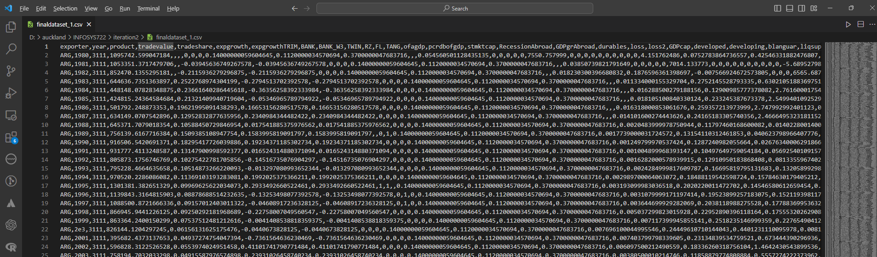

Most of the variables in this data have a numerical type, some flag type and some categorical type variables are also included.

It is difficult to guess what the data in this column is about through some headers, but there are exceptions, such as "year", "country" and "trade value", and the last column "contcrisis" uses 0 and 1 to indicate whether it occurs Banking crisis.

Import it into SPSS Modeler to get a better view:

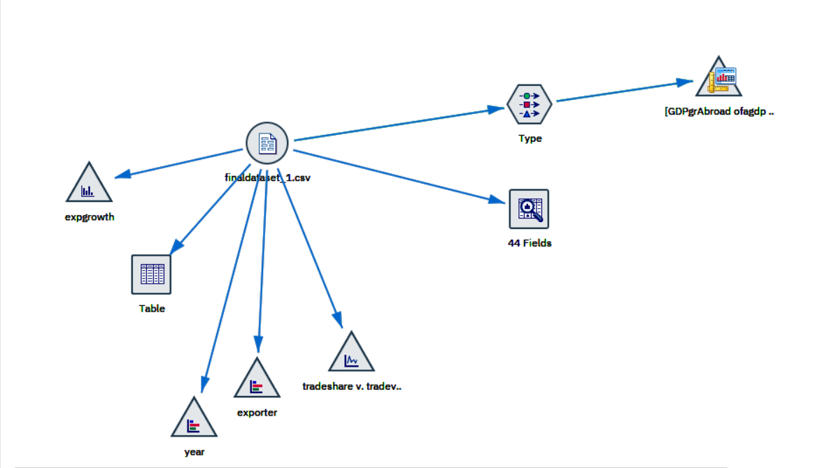

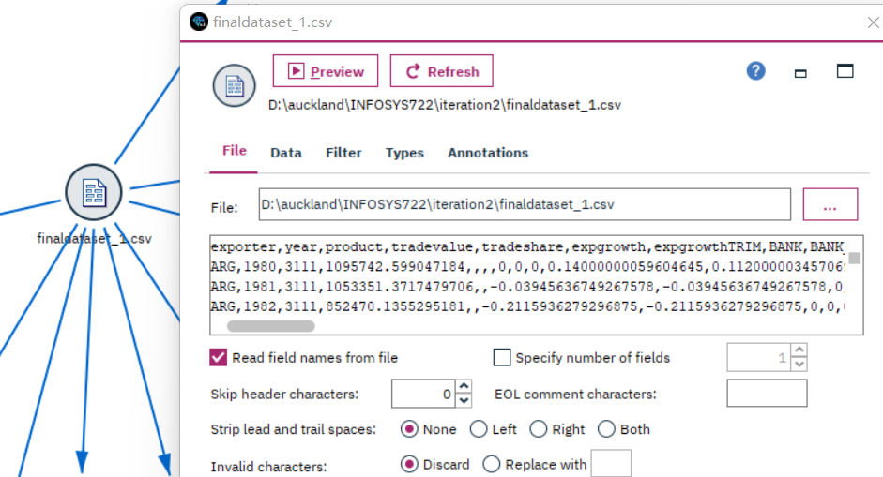

In this iteration, it is not necessary to fully understand the meaning of all headers. First, find the variables most related to “contcrisis” through analysis, and then understand the meaning of these related variables.

A data understanding stream is created in SPSS Modeler.

It could be seen that there are many missing values from the data audit in this stream.

The maximum value, minimum value, mean value, standard deviation, skewness are also clearly listed in the data audit.

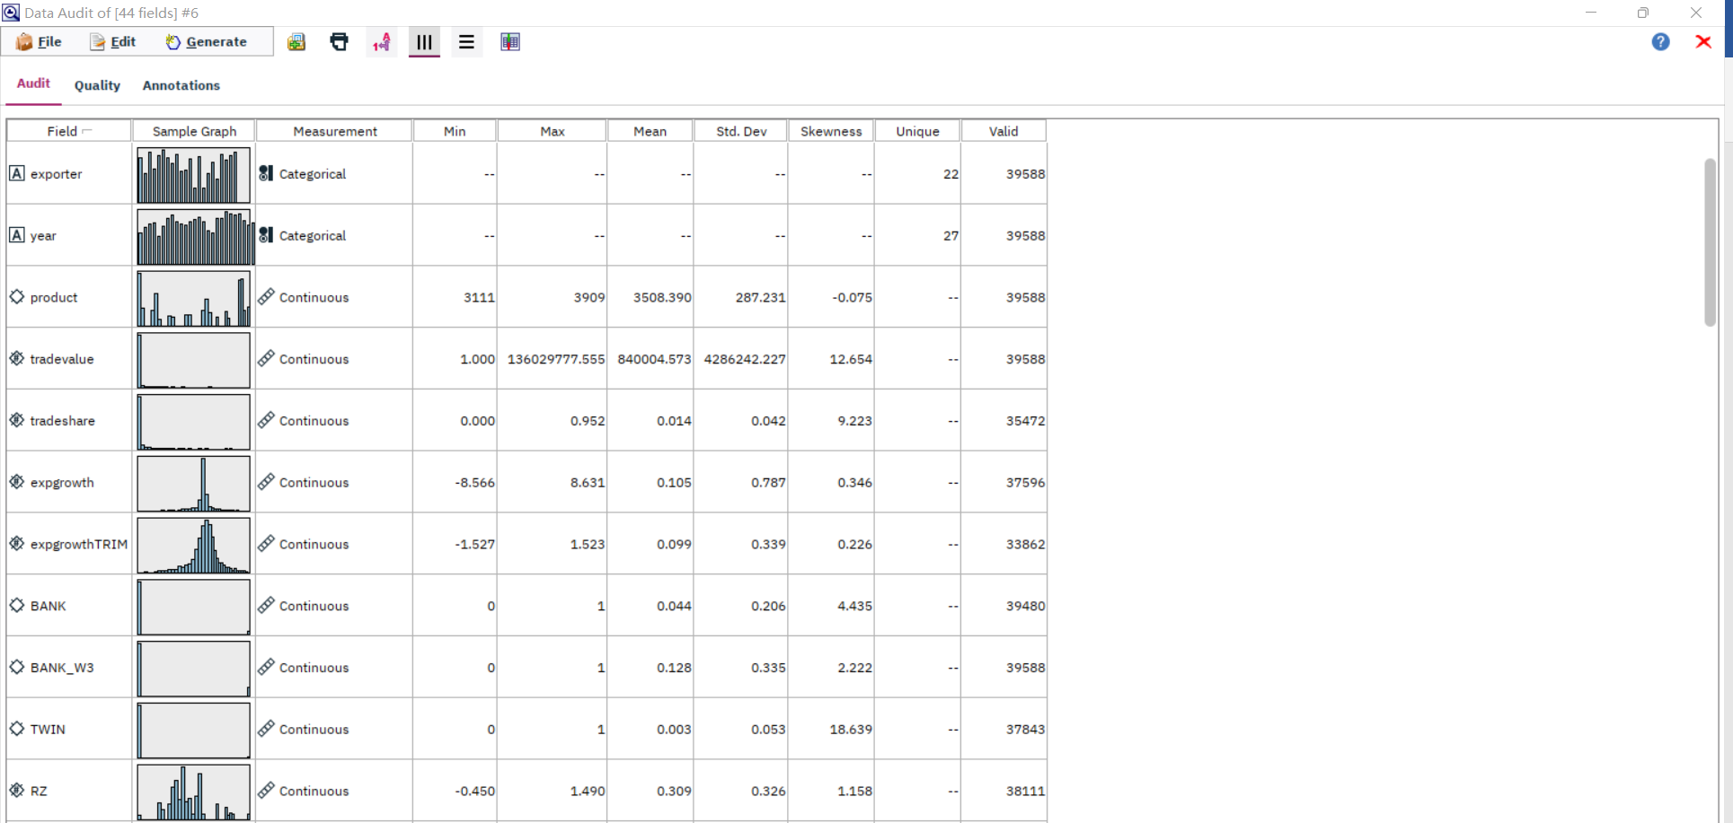

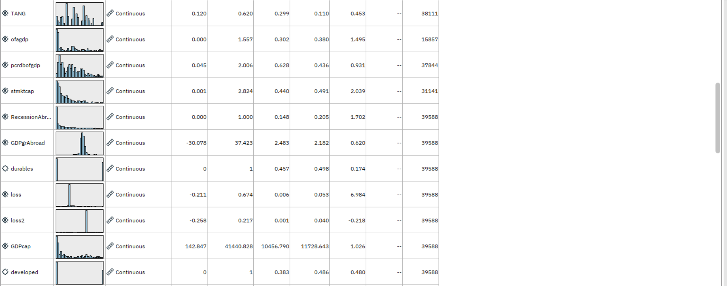

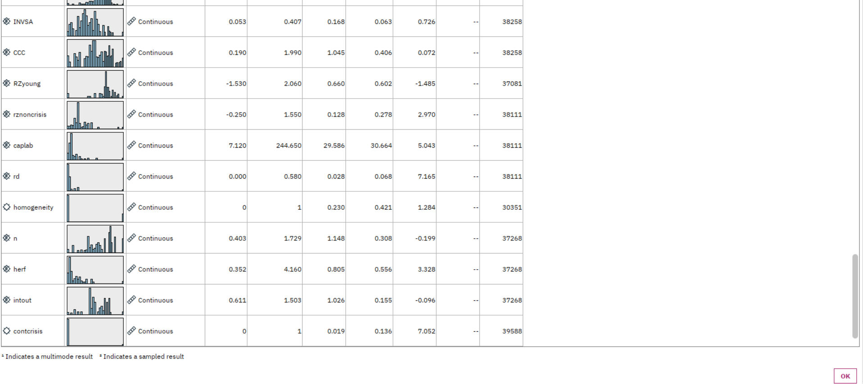

Here are some specific fields in this data:

Some Graphs is created to describe those fields.

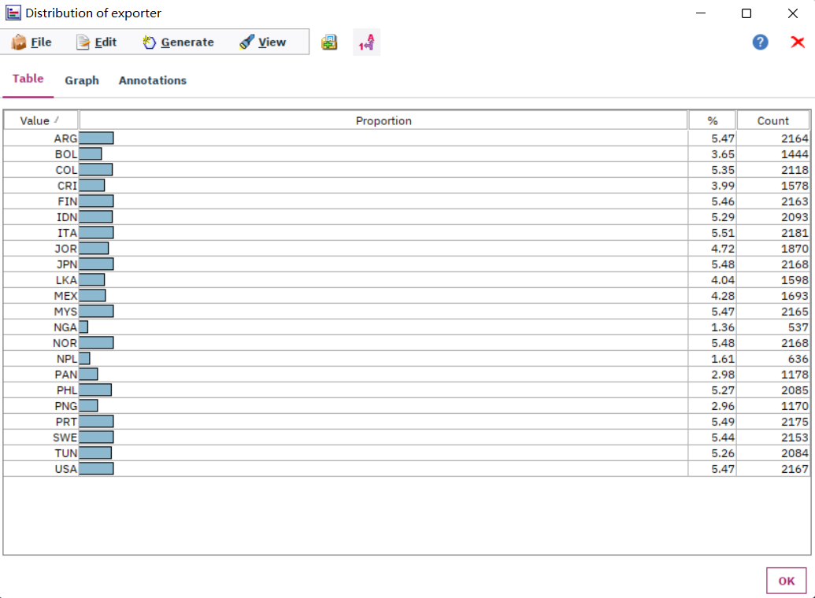

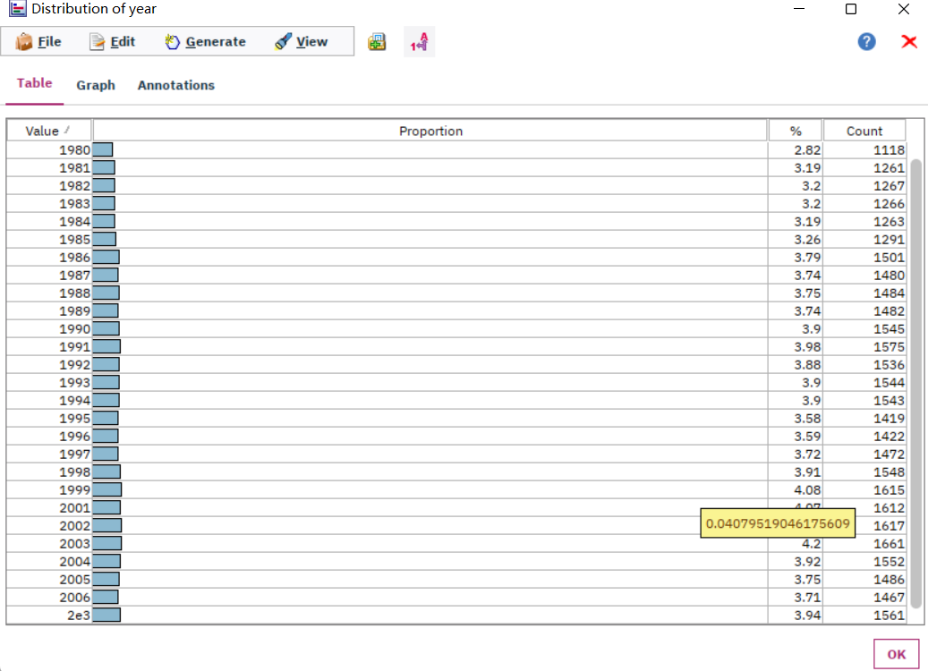

Here, 2e3 should represent the year 2000.

## Data Exploration

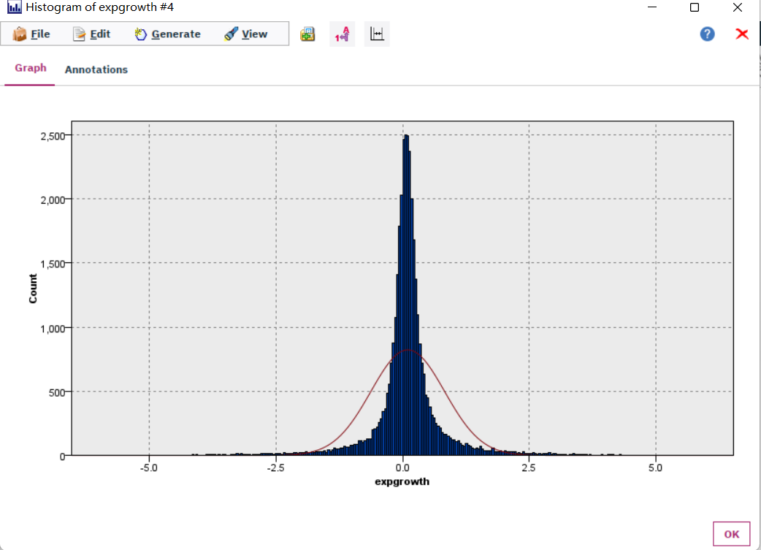

The export growth rate has a normal distribution.

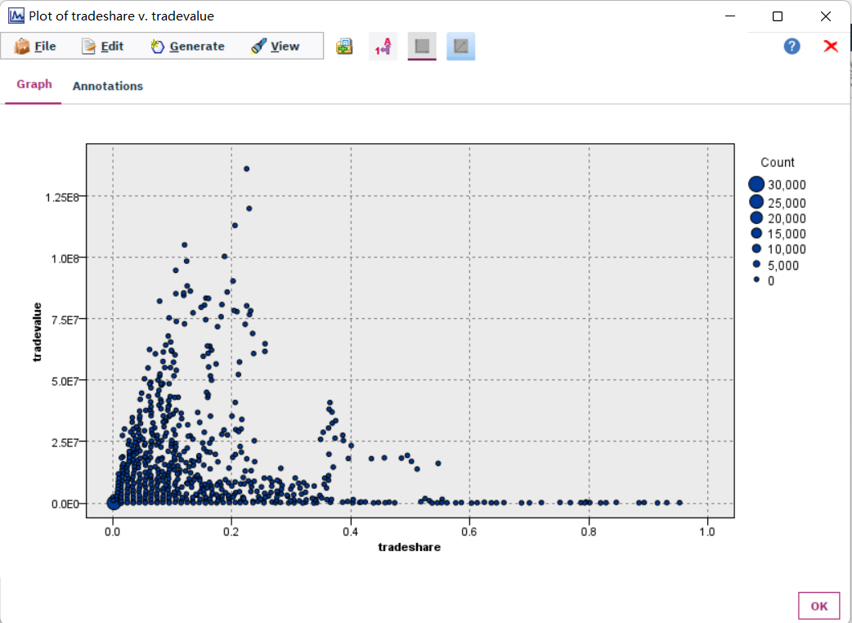

All the points printed are in an angle.

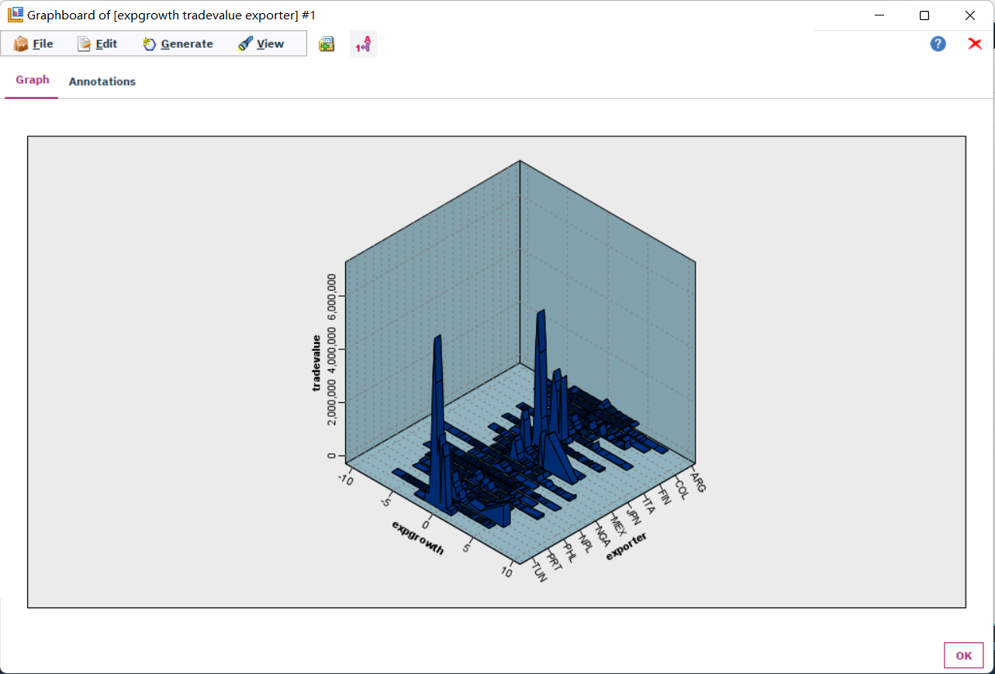

There are 2 obvious peaks in the data of JPN and TUN.

### Exploration of most important predictors(features)

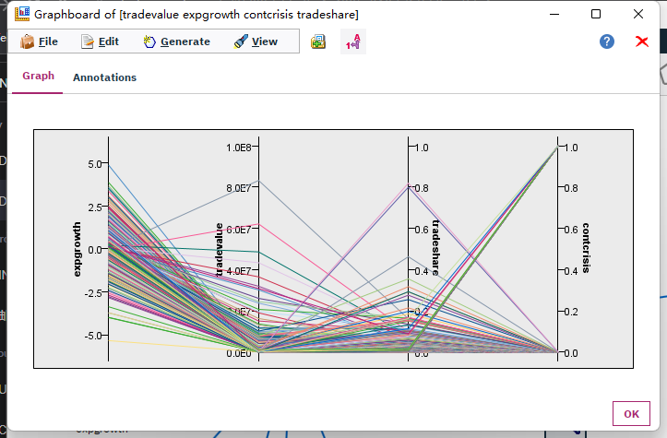

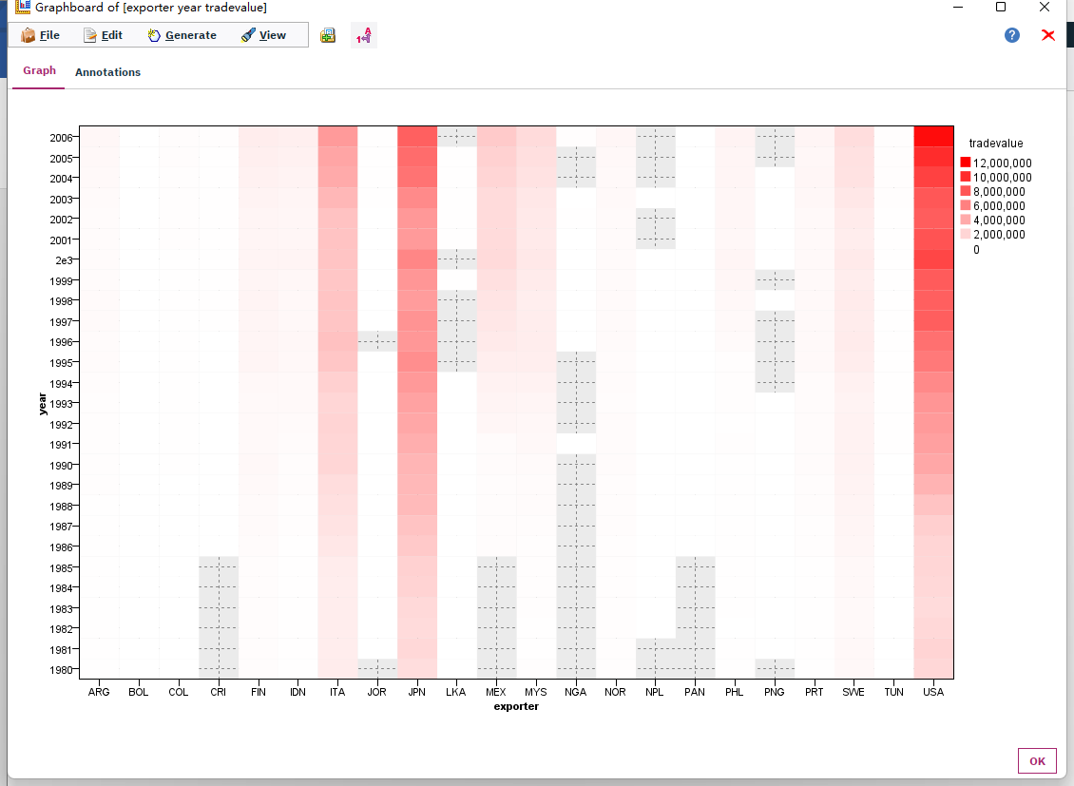

## 2.4. Verifying Data Quality

### 2.4.1. Missing Values and Extreme Values

The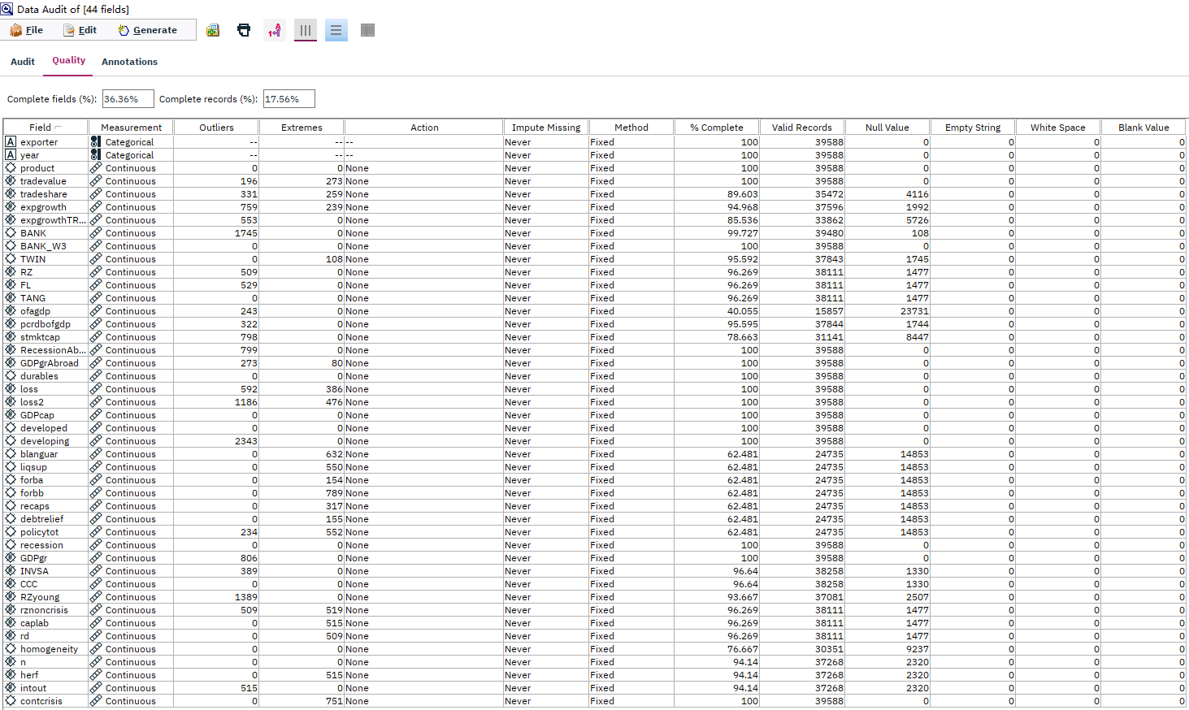

It could be seen that the “ofagdp” field has the worst complete percentage with a 40.055%, which means this field is useless for our data mining for its about 60% is missing values.

### Extreme Values Explained and Feature Value (coding) Inconsistencies

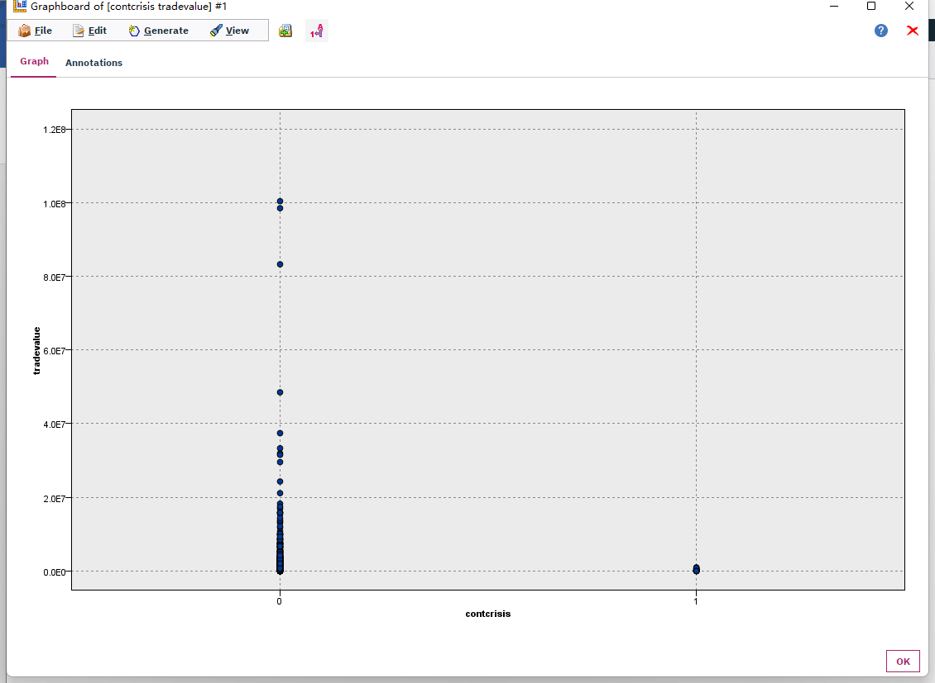

The main cause of this is the measurement of those fields are set to wrong choices.

### 2.4.3. Measurement errors

The measurement errors in this dataset is not cause in the data collection process, but in the csv file reading process.

The “developing” field has the largest number of outliers, but it is because of the measurement is set to “continuous” wrongly, as it is well known the countries could be classified to developing countries and developed countries. The measurement must be changed in the data preparing phase.

Overall, the quality of this data is good enough to support this study.

# 3. Data Preparation

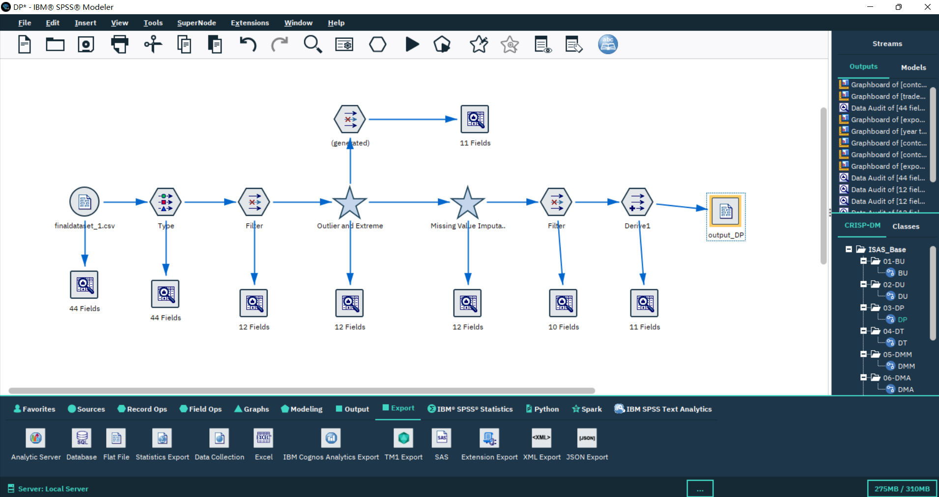

## Select the data

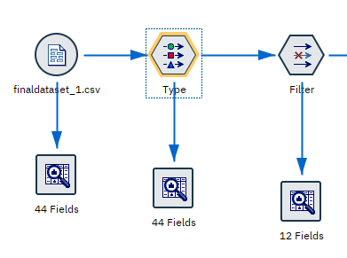

First make some change to the “measurement” field in the type node.

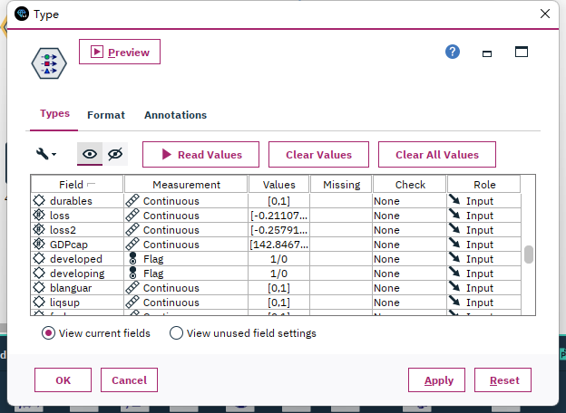

This study needs to build models for developed countries and developing countries separately, so a filter node is needed to select the data collected from developed countries, and in the other branch, select the data collected from developed countries.

## Clean the data

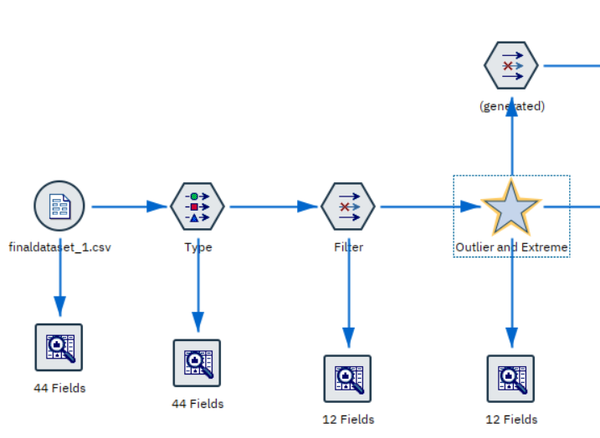

Dealing with the extremes:

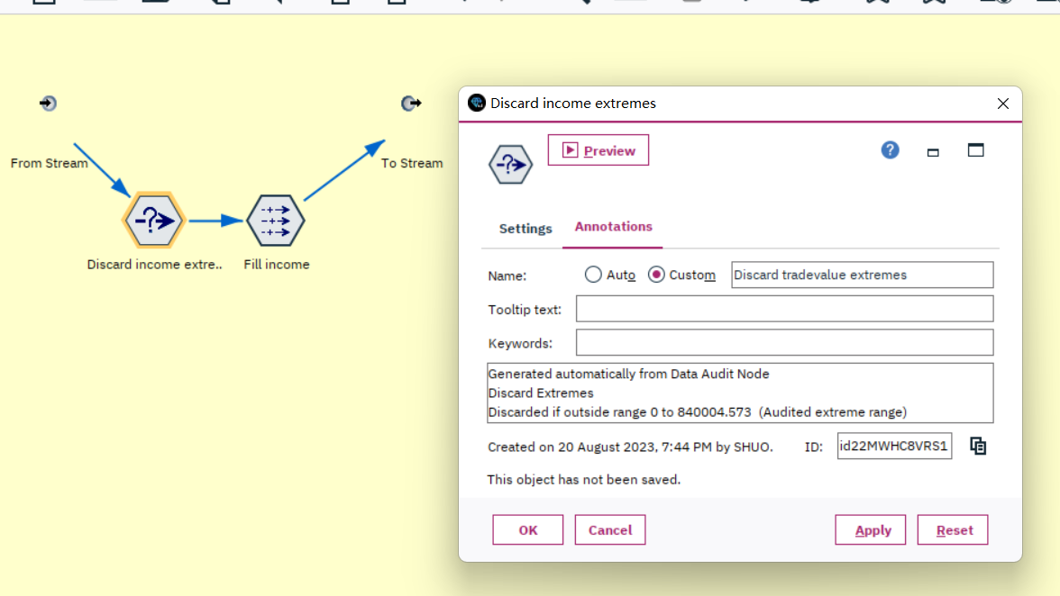

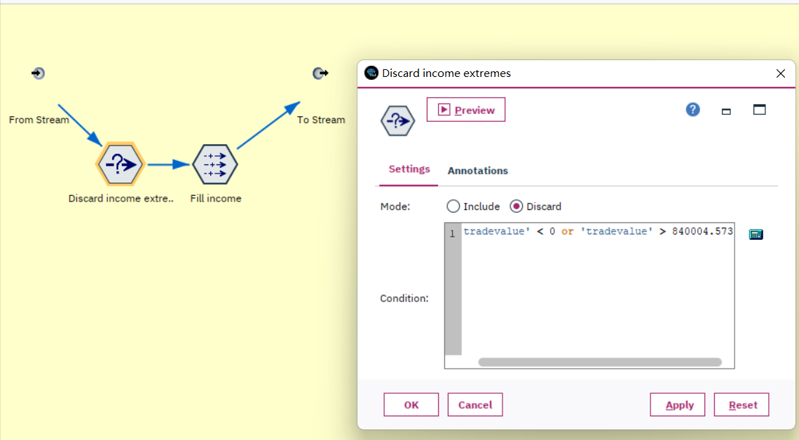

Dealing with the NAs:

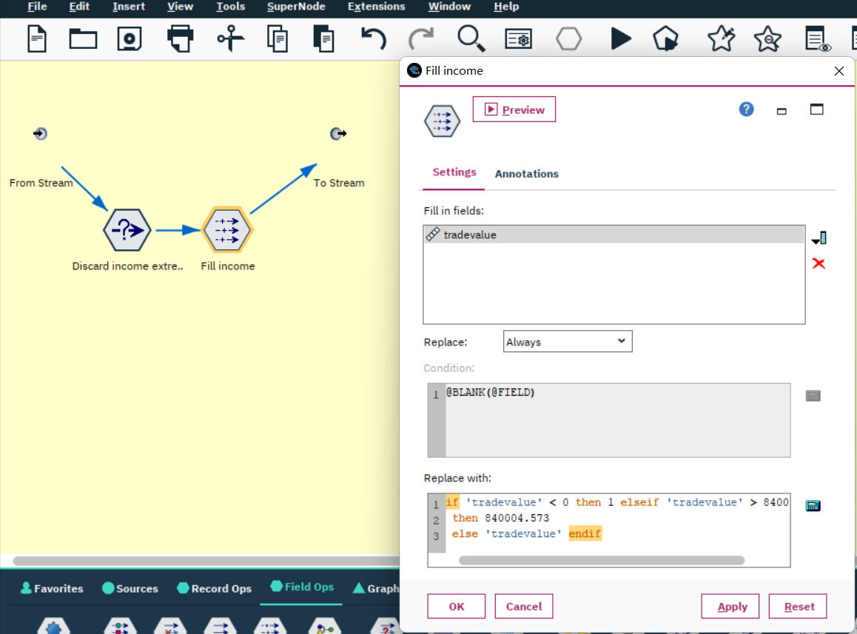

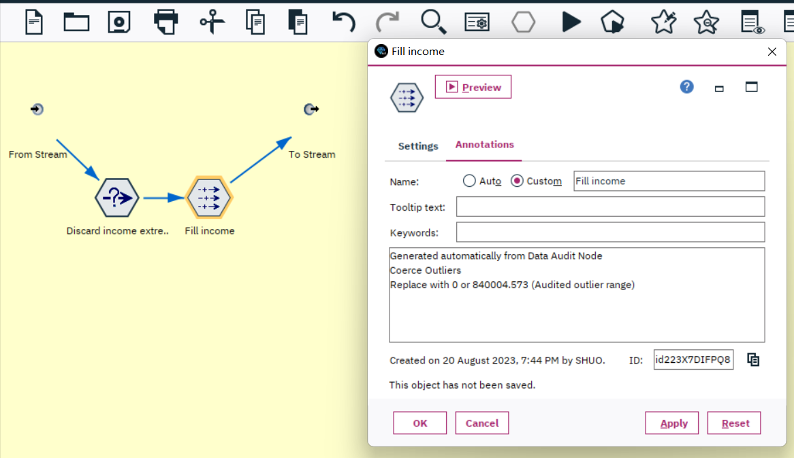

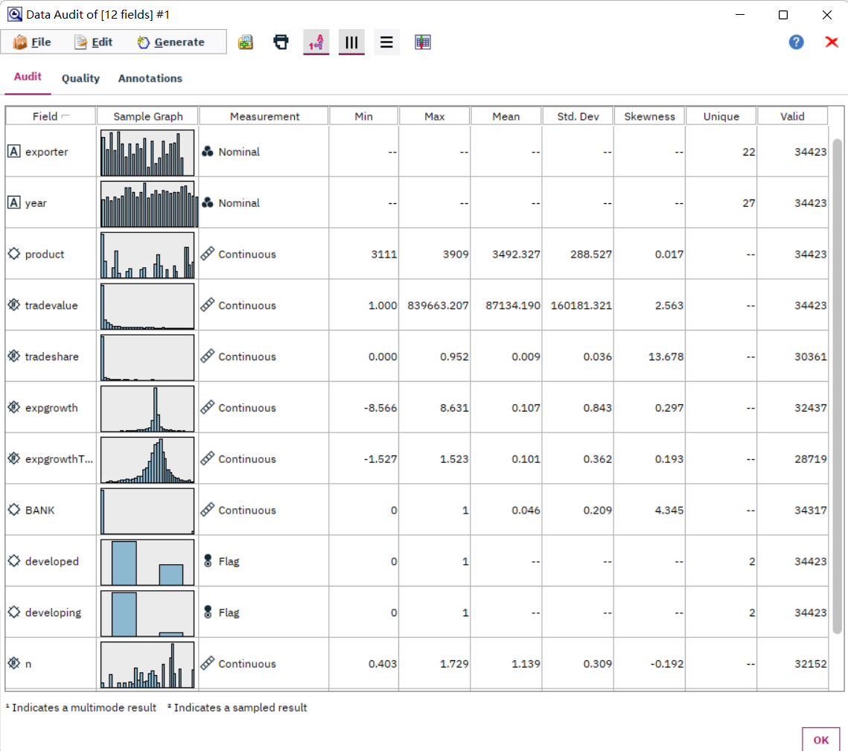

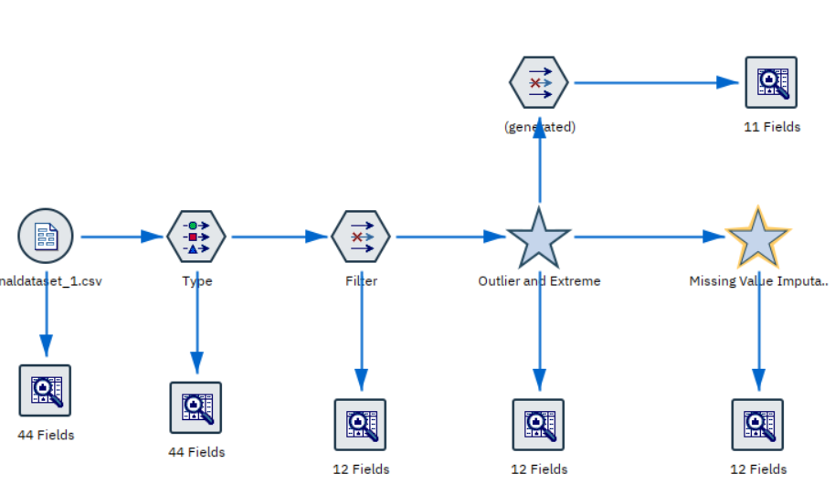

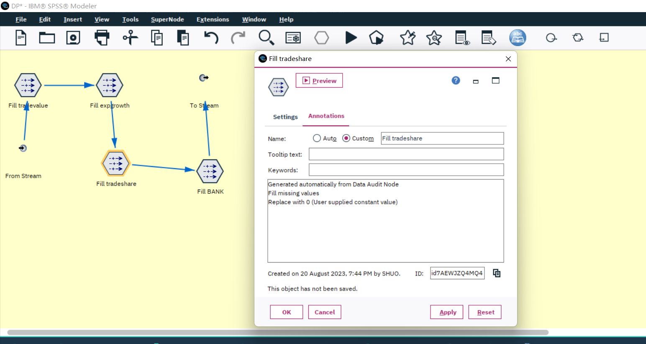

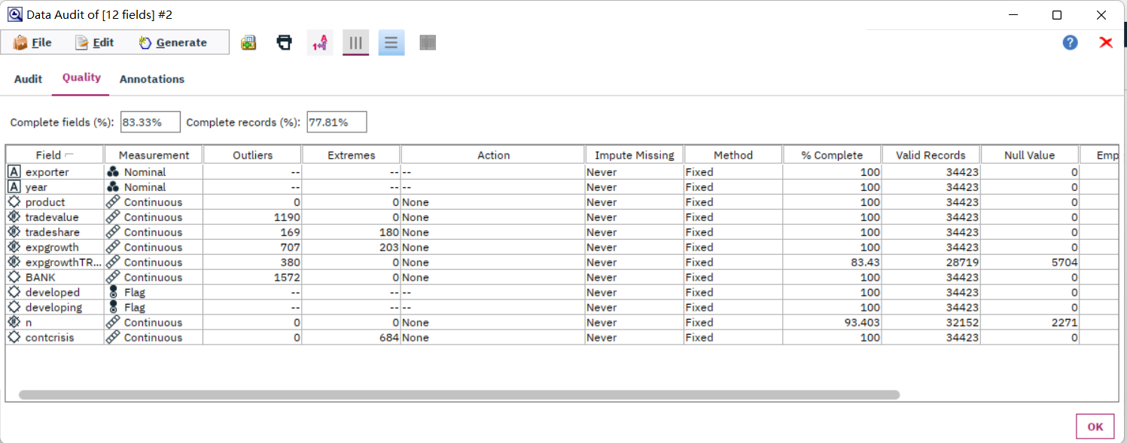

The data quality increased a lot, the complete fields increases from 36.36% to 83.33% and the complete records increased from 17.56% to 77.81%.

There are still 2 fields with many null values, filter them out.

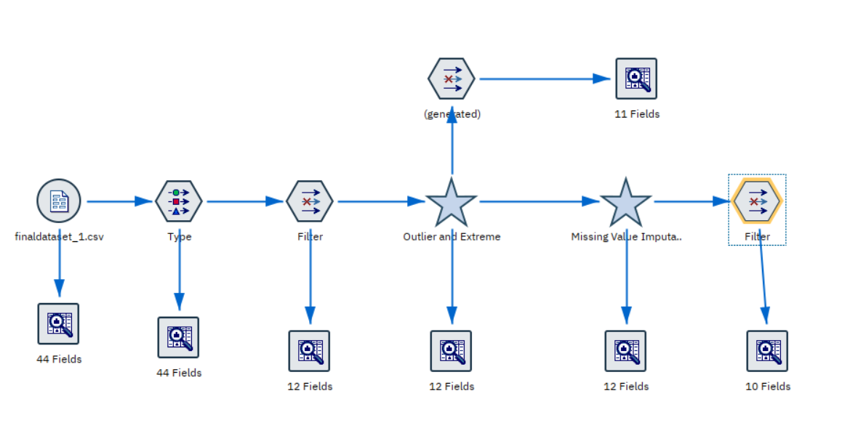

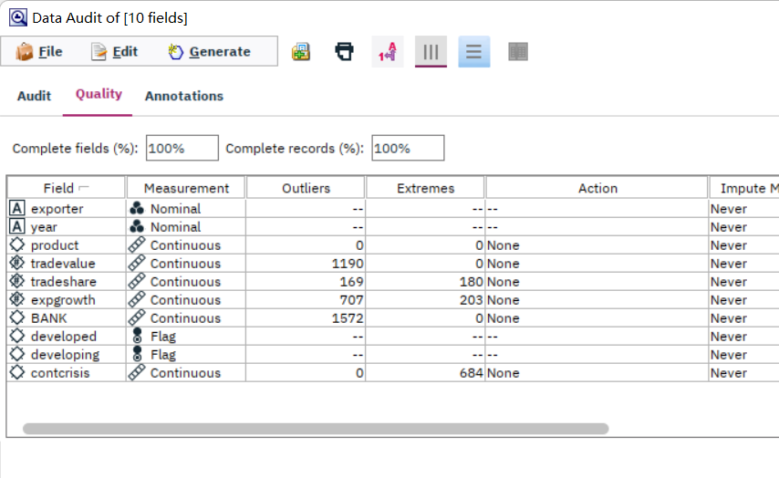

Now the data is 100% complete.

## Construct the data

Construct a new column with *“tradevalue”* and *“contcrisis”*. The value of the new field is calculated by *“tradevalue”*“contcrisis”* .

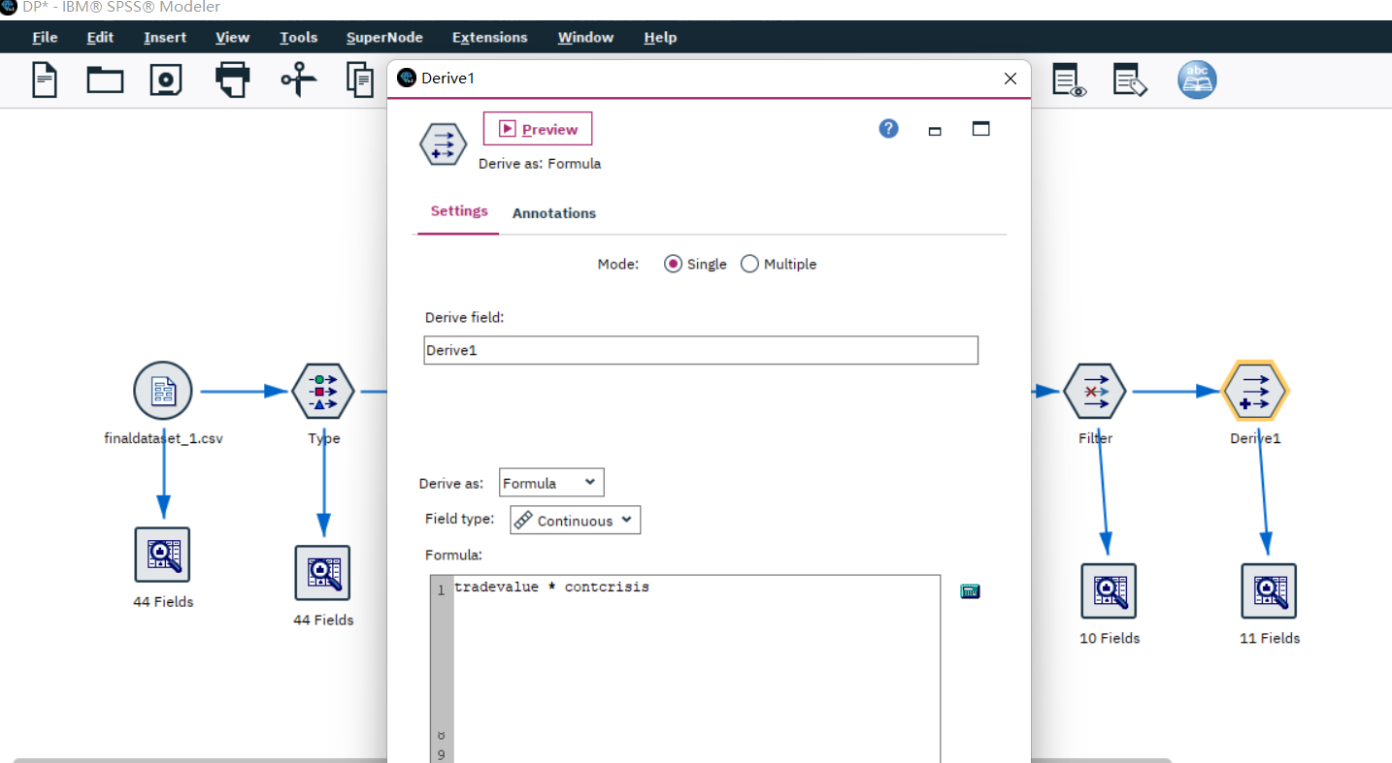

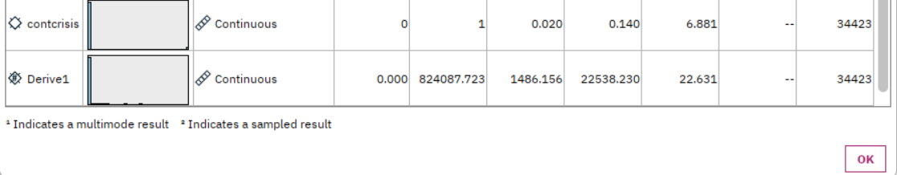

## Integrate various data sources

Since the finaldataset_1.csv is the only data source the iteration has, there is no need to integrate other various data sources.

## 3.5 Format the data as required

After data cleaning and data constructing , the format is already as required.

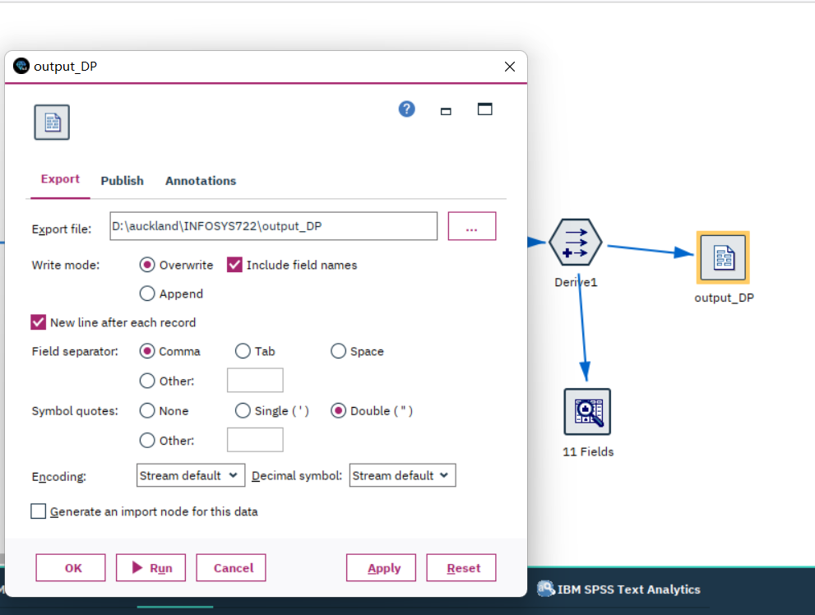

Save to disk after all the data preparation is done.

# 4. Data Transformation

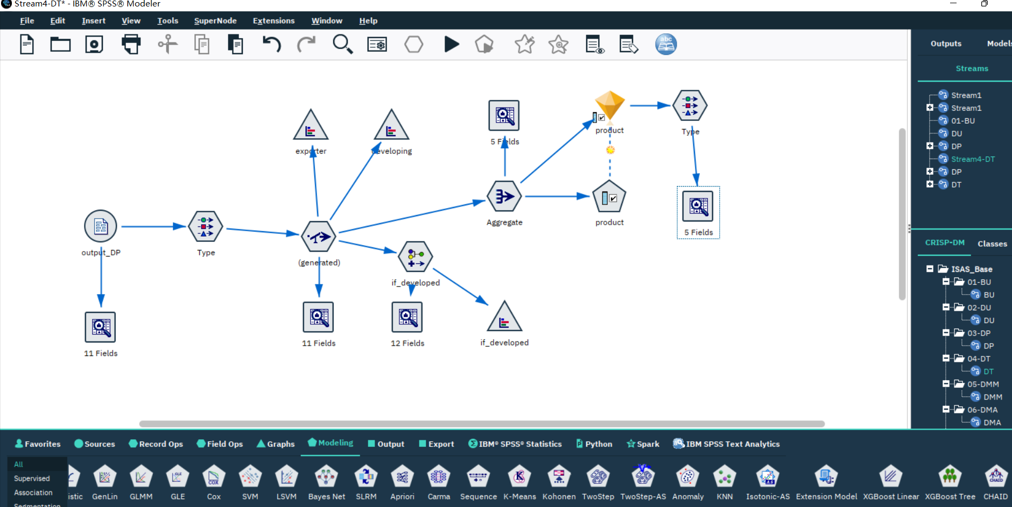

## Reduce the data

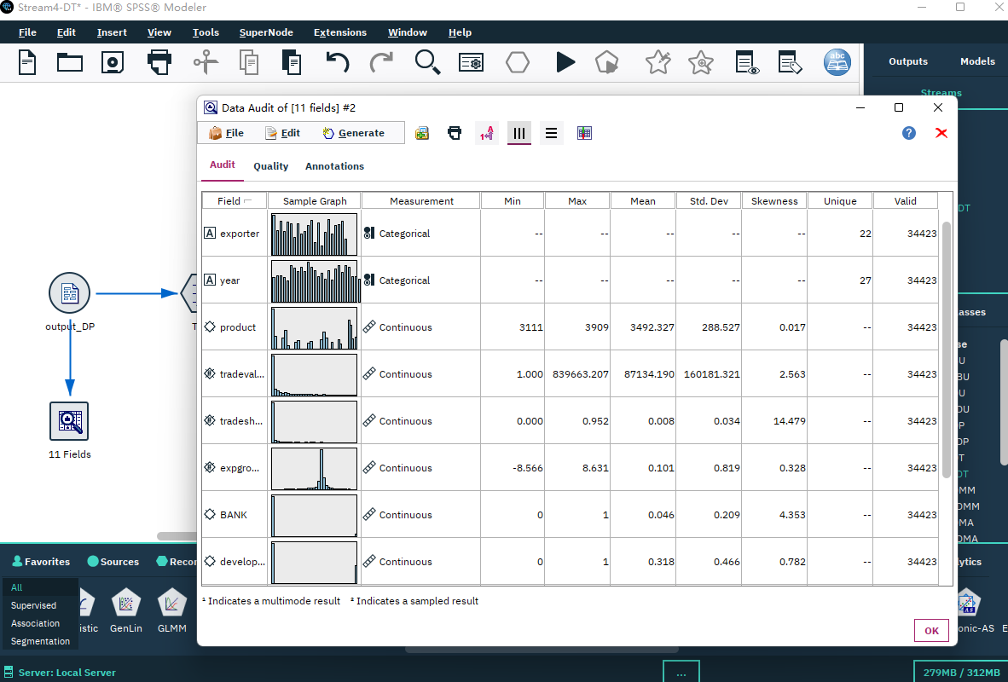

Using data audit node to visualize the input of this phase, which is also the output of the last data preparation phase.

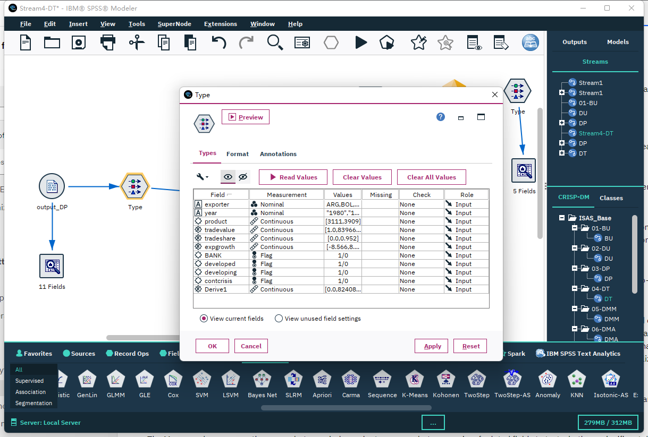

Organize the measurements of the fields in Type node.

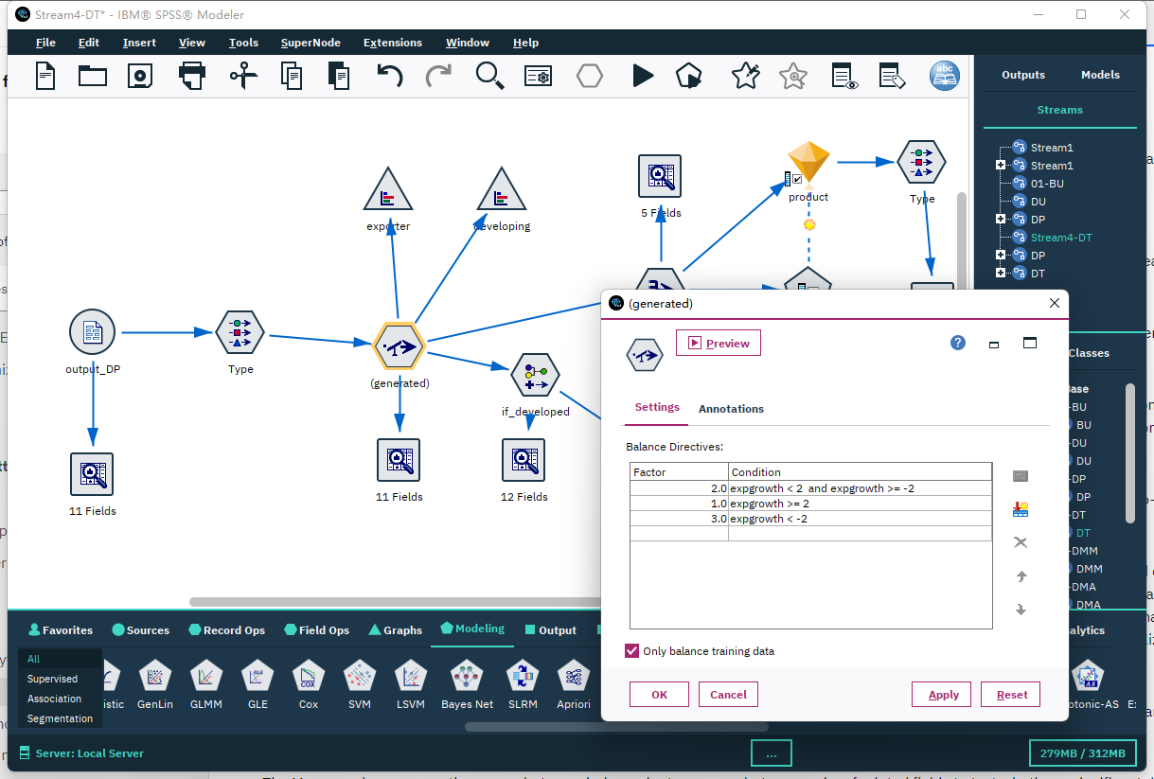

Set the different export growth speed.

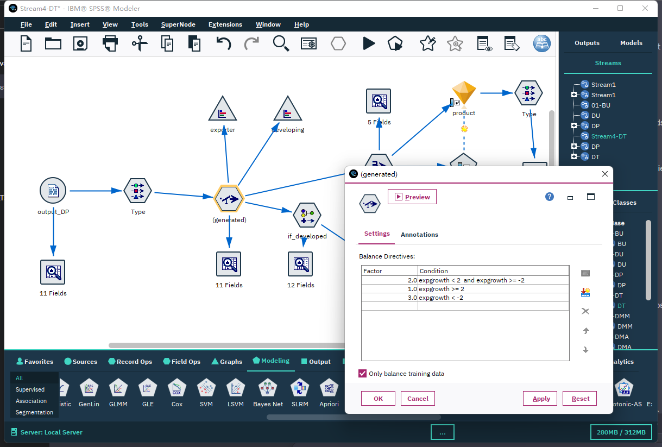

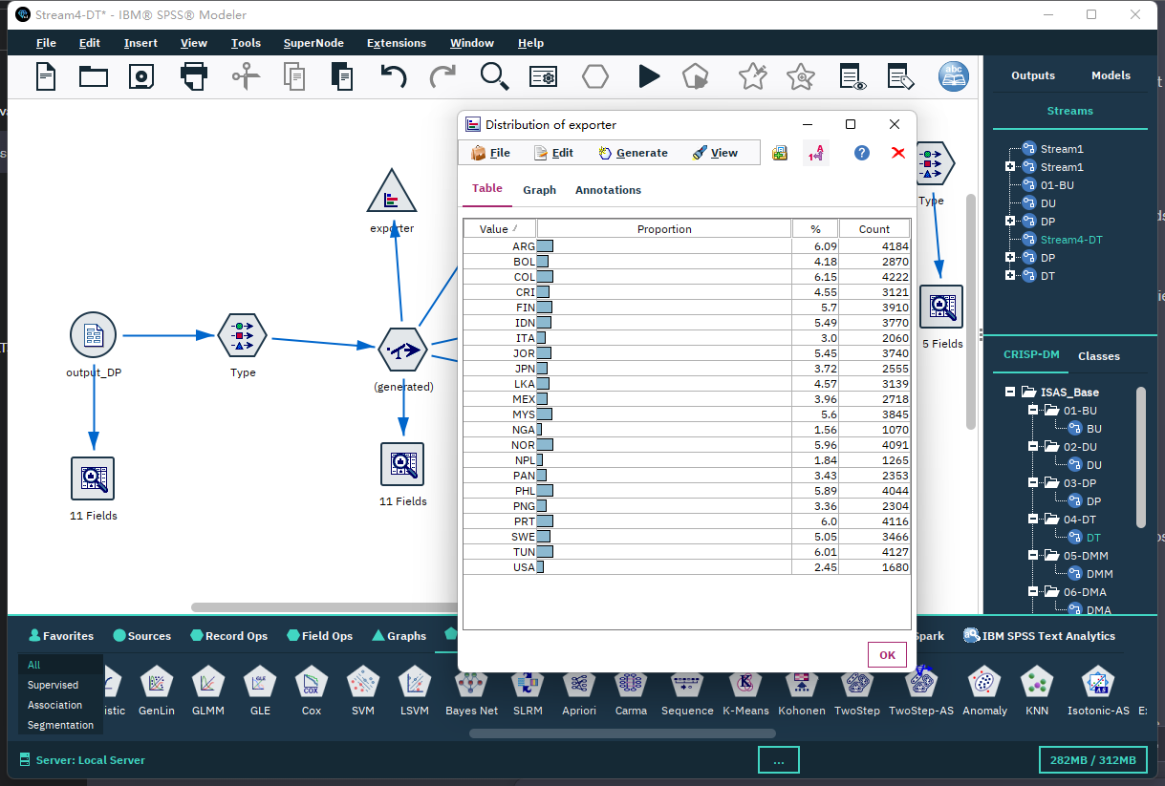

Using aggregate node to summarize data, calculating the mean and sum.

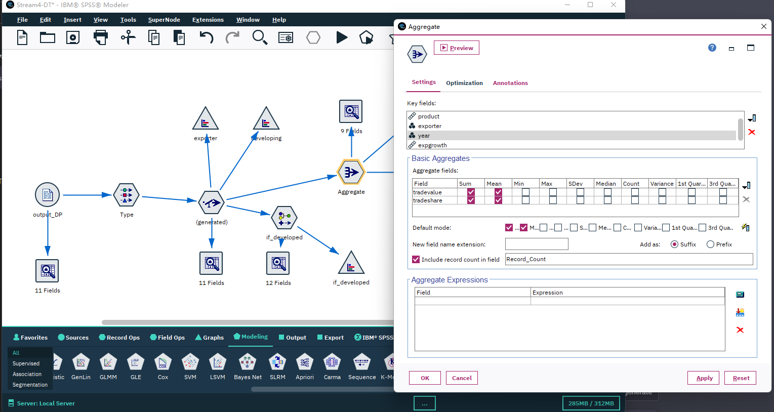

The result of aggregate:

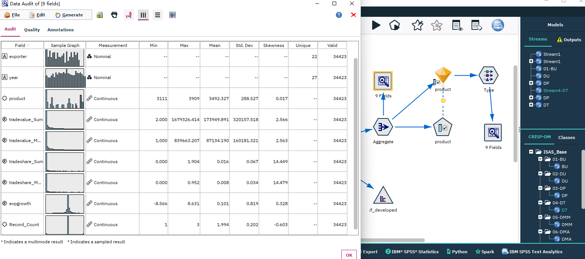

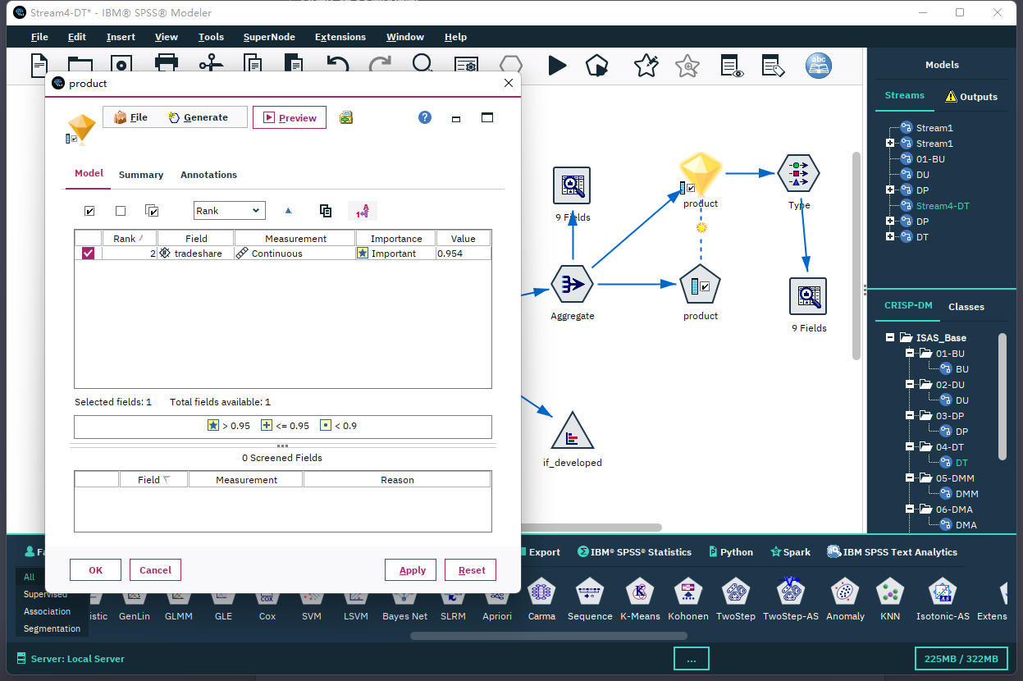

Combine the developing field and develop field:

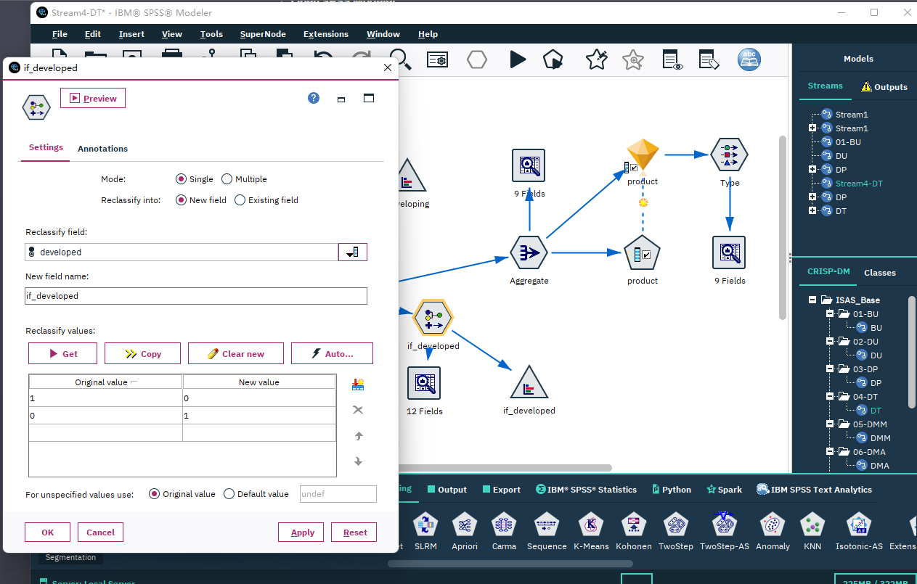

The result:

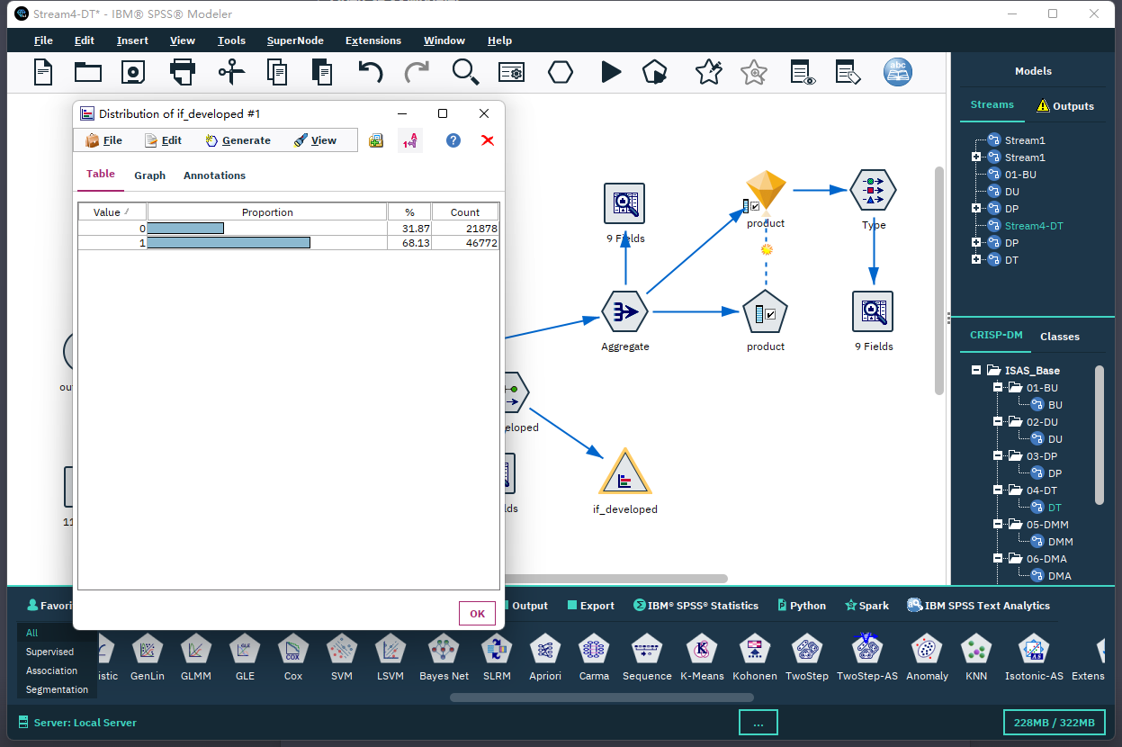

## Project the data

Project the data by using Feature Selection node:

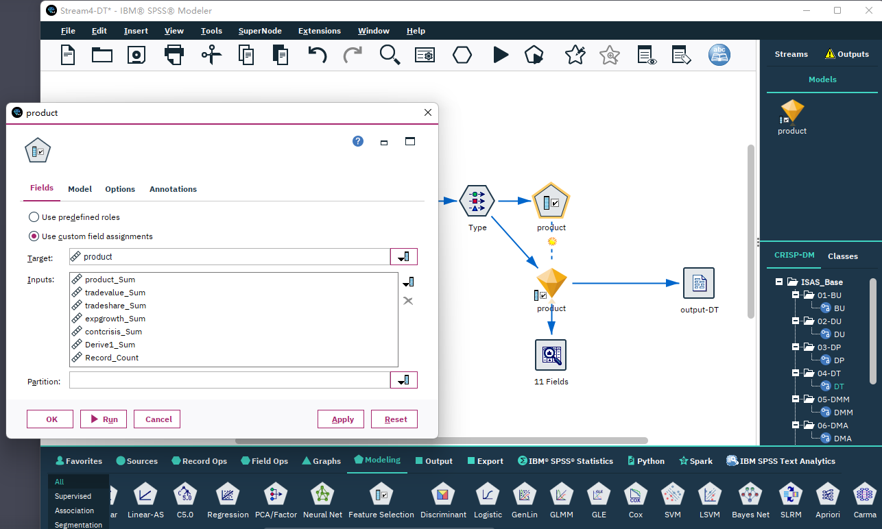

Export all the data in this phase to a csv file named “output-DT.csv”

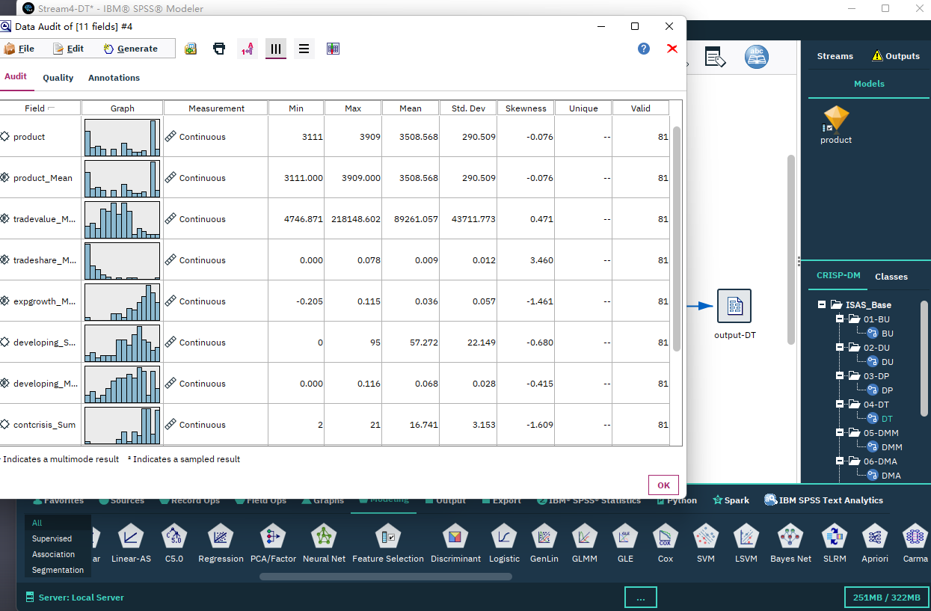

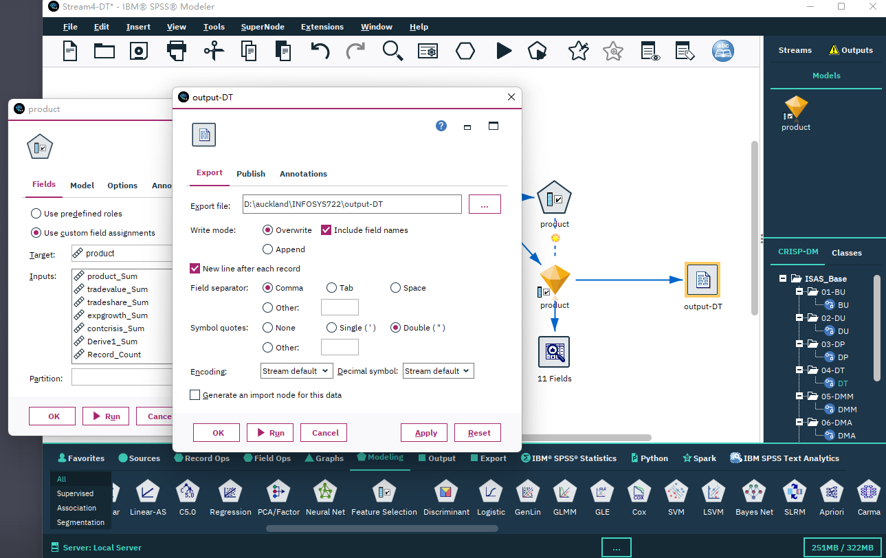

# 5. Data-Mining Method(s) Selection

## 5.1 Match and discuss the objectives of data mining (1.1) to data mining methods

In this study, a binary classification is wanted, based on a mix of continuous and categorical inputs.

We have known outcomes, so supervised model should be used.

But the data is only collected from 1980 to 2007, when there was a global banking crisis. So, a linear regression is also needed to predict the data from 2008 to 2023. To get this model, the data need to be split at 2005, the data before 2005 will be used to train the regression model of trade value and other useful fields to build the binary classification model, and the data after 2005 will be used to test the accuracy of the model.

And then, train a bank crisis detect model with collected data. The data set will be split into 2 sets: training set (80%) and test model (20%).

## 5.2 Select the appropriate data-mining method(s) based on discussion

For the linear regression model, several methods can be considered:

1. ARIMA: A popular method for time series forecasting.
2. Linear Regression: Can be used if the sales trend over time is linear or can be made linear with transformations.
3. Neural Networks: Can capture complex patterns

Evaluation:

After building the Linear Regression model, use metrics like Mean Absolute Error (MAE), Mean Squared Error (MSE), and R-squared to evaluate its performance on a validation set.

For the binary classification model, several methods can be considered:

1. Logistic Regression: Good for a baseline model, especially if relationships are linear.
2. Decision Trees or Random Forest: Can handle both numerical and categorical data and provide feature importance.
3. Support Vector Machines: Useful for non-linearly separable data

Evaluation:

After building the Random Forest model, use accuracy, precision, recall, and the AUC-ROC curve to evaluate its performance.

# 6. Data-Mining Algorithm(s) Selection

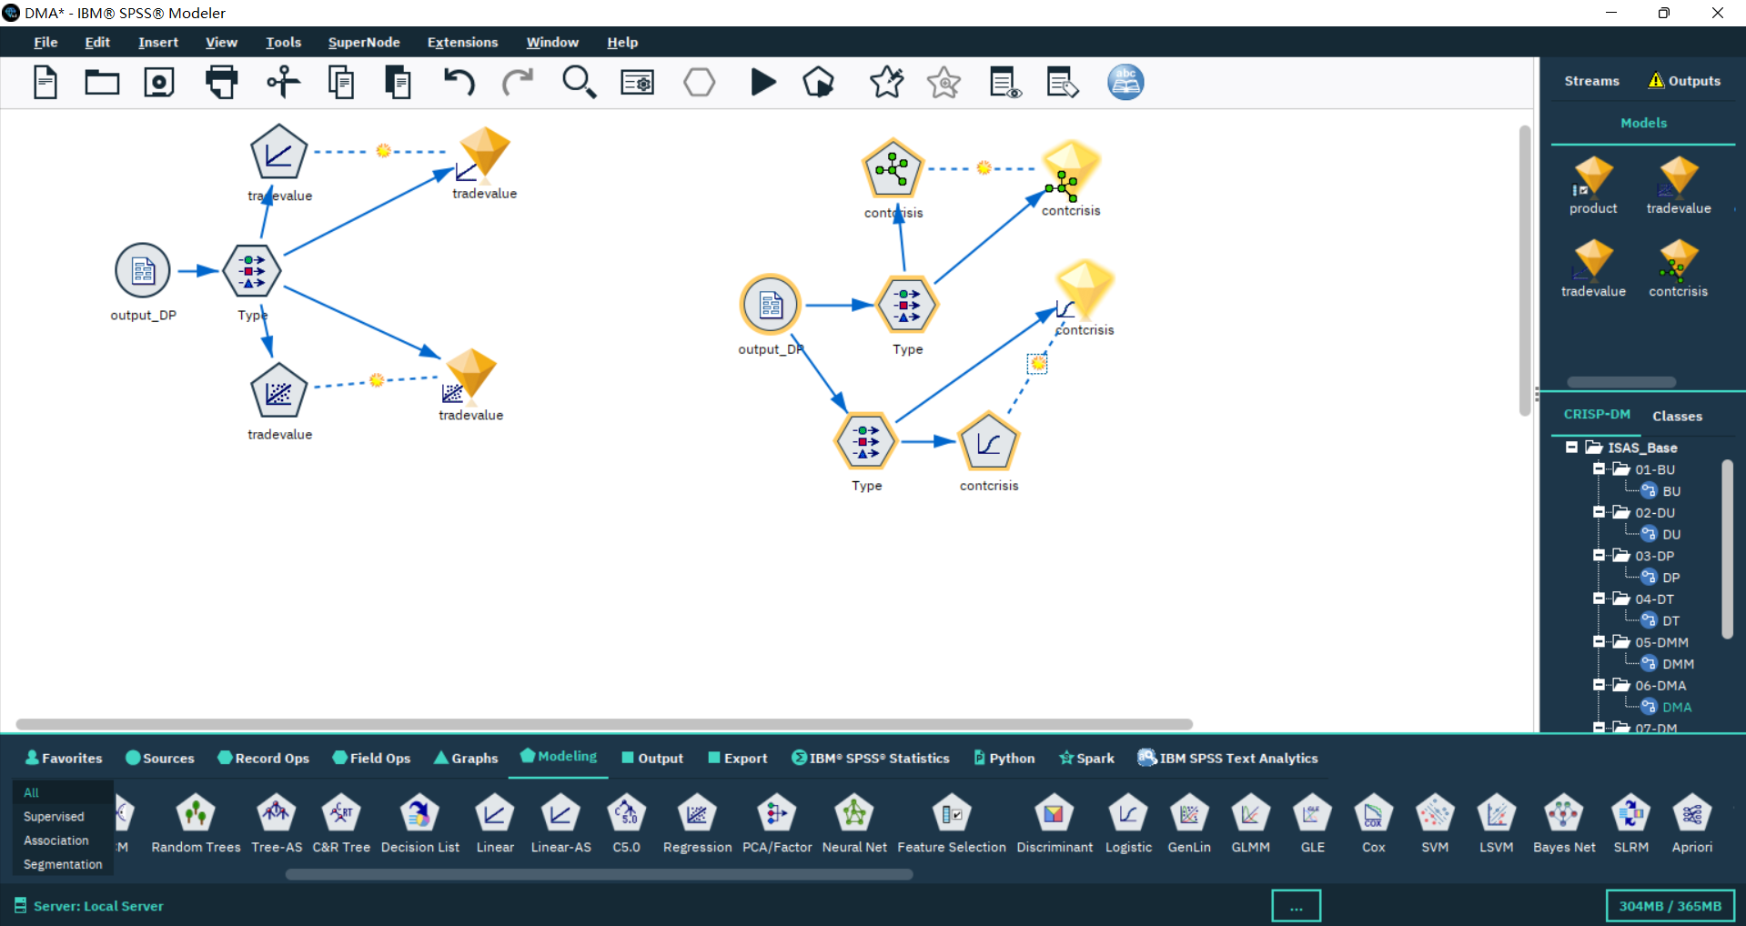

## 6.1 Conduct exploratory analysis and discuss

### 6.1.1. First Data-Mining Objective: The Linear Algorithm

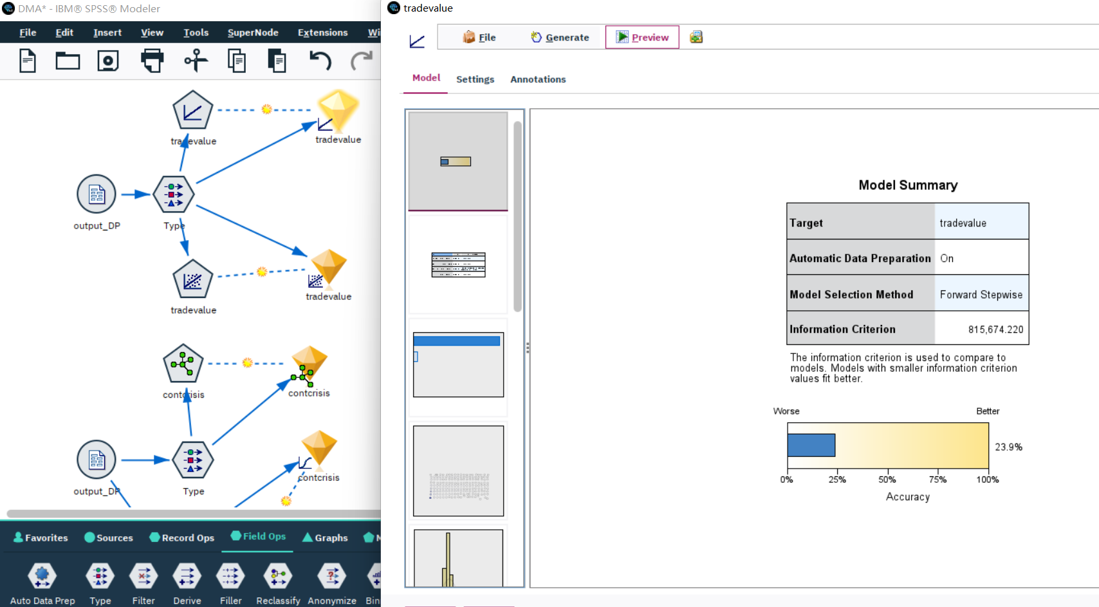

### 6.1.2. First Data-Mining Objective: The Regression Algorithm

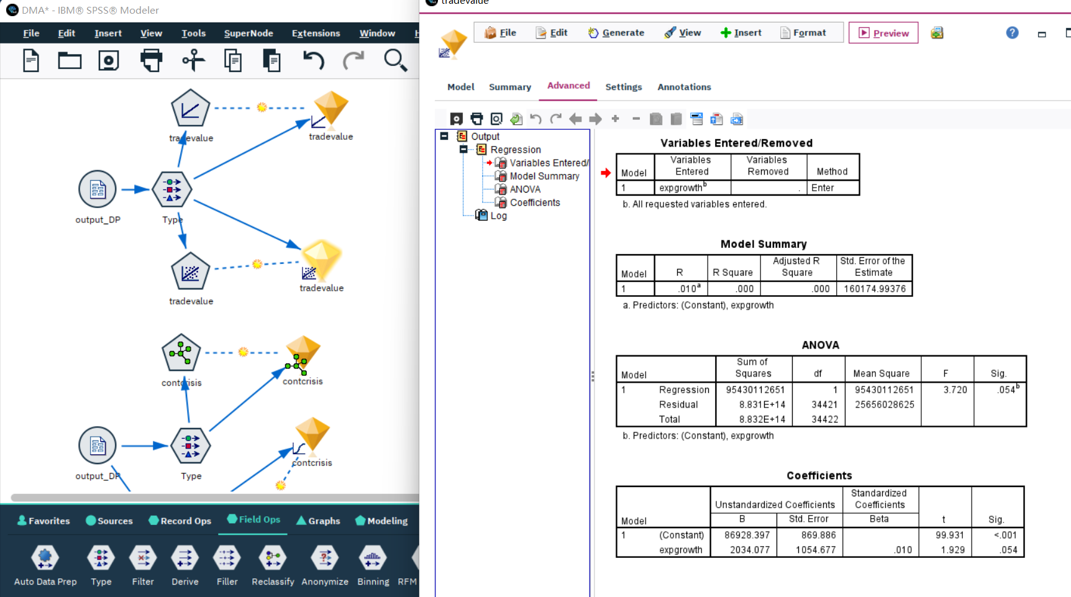

### 6.1.3. Second Data-Mining Objective: The Classification Algorithm

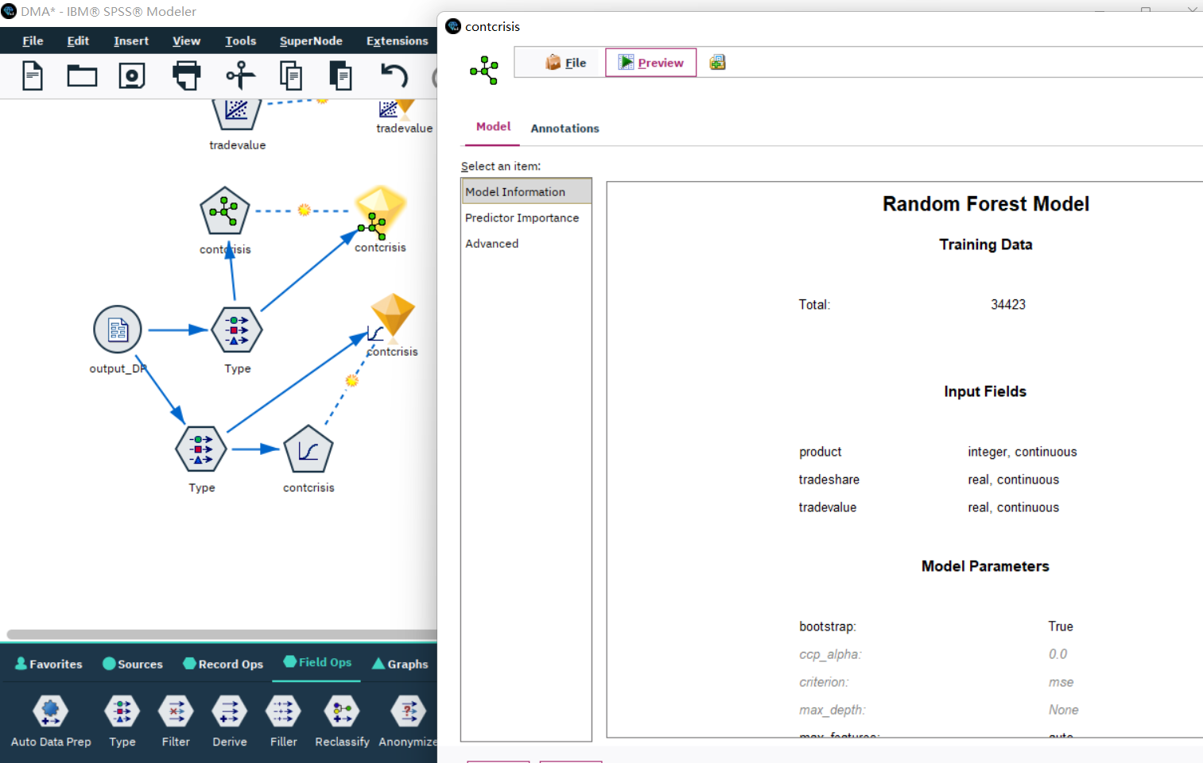

### 6.1.4. Second Data-Mining Objective: The Logistic Regression Algorithm

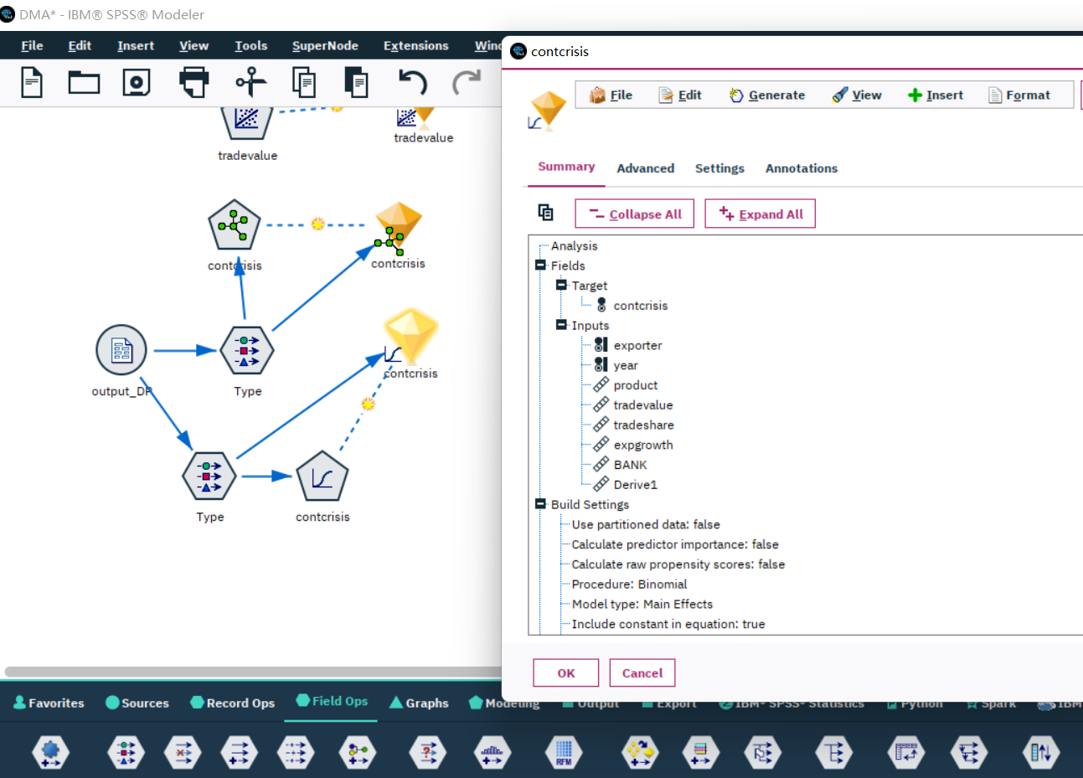

### 6.1.5. Second Data-Mining Objective: SVM

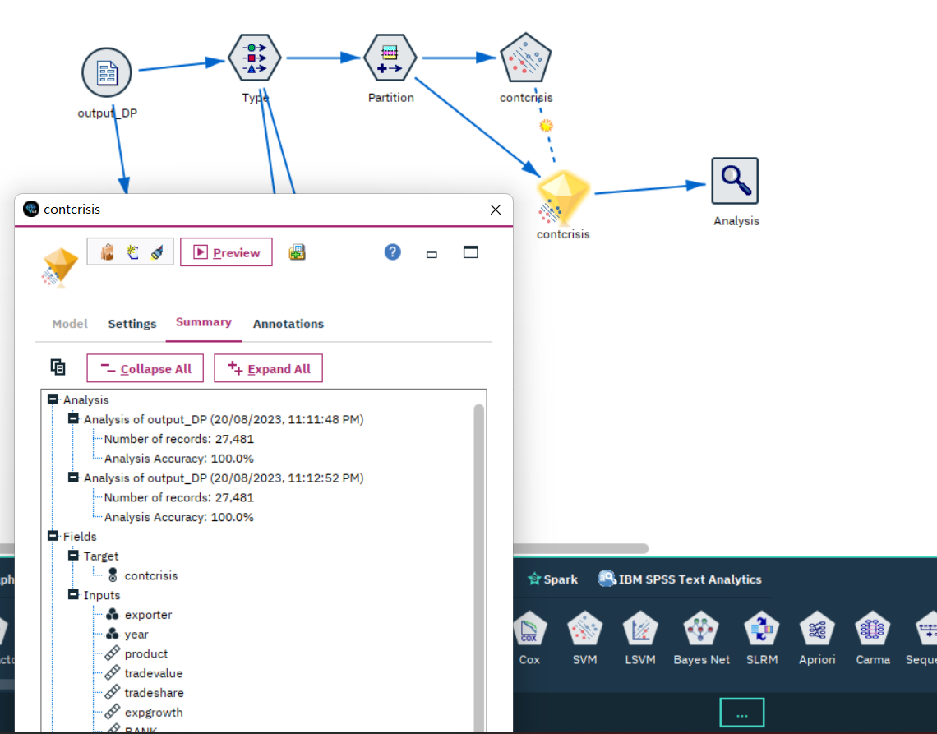

## 6.2 Select data-mining algorithms based on discussion

For the first objective, linear algorithm should be chosen. For the time series analysis failed because the data format of YEAR field is still string. This must be solved in the next iteration.

So, find out which field gives a largest influence on the trade value field should be the new first objective of this data mining process, since trading value is an important indicator to measure the vitality of the world economy

For the second objective, SVM should be chosen. This algorithm handles mixed types of data well, are interpretable, and has shown success in similar problems. It’s also agreed to evaluate models based on accuracy and recall, given the high cost associated with false negatives.

## 6.3 Build/Select appropriate model(s) and choose relevant parameter(s)

For the linear model:

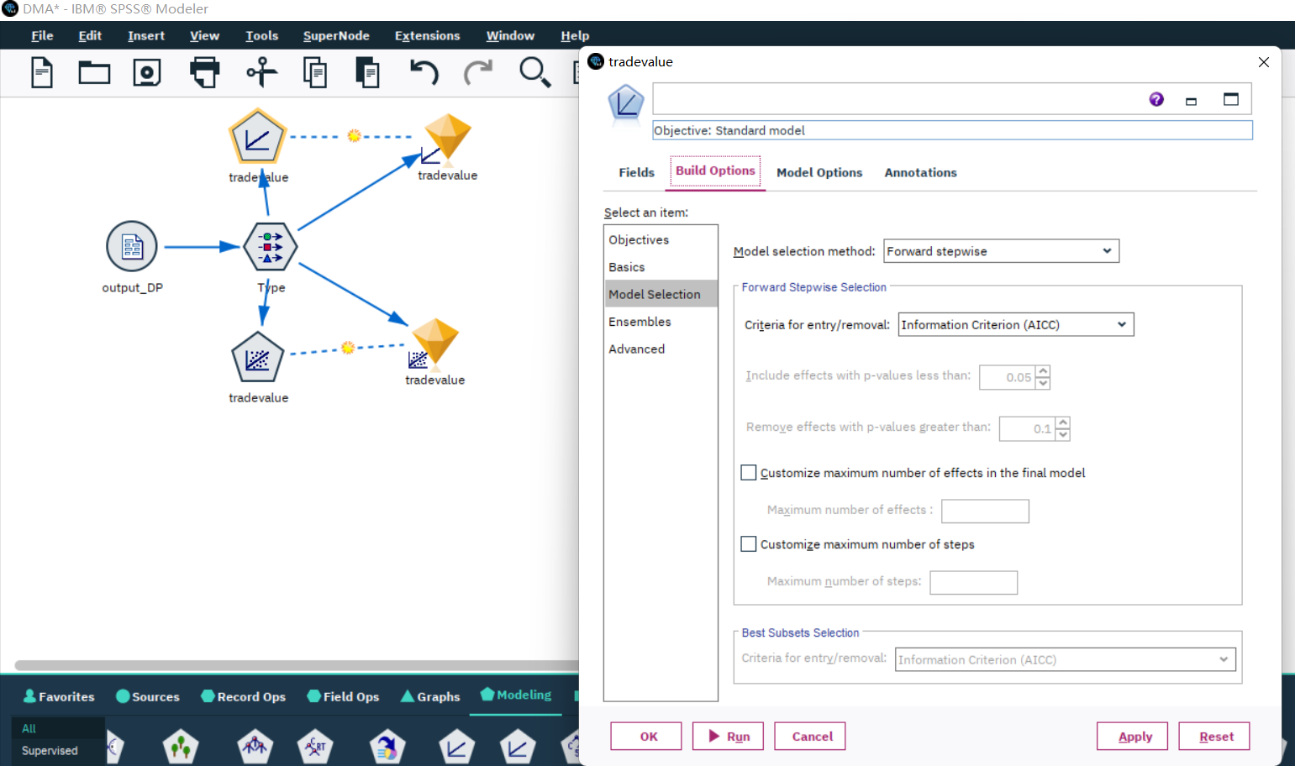

The model selection method is set to “forward stepwise”, criteria for entry/removal is set to”AICC" the others are set to default.

For the random forest, the number of trees to build is set to 10, minimum leaf node size is set to 1, number of feature to use for splitting is set to “auto”

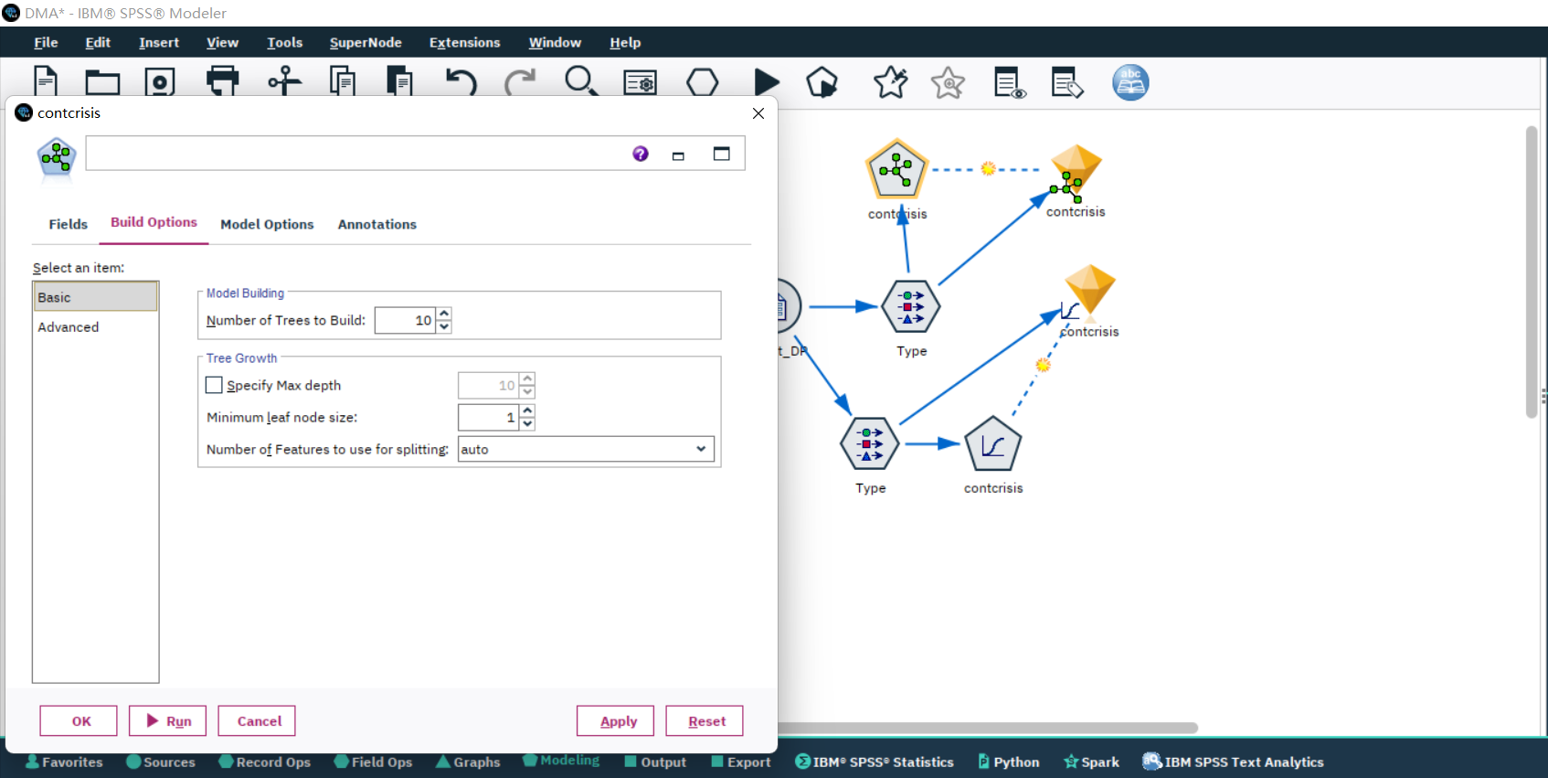

For the SVM, only need to set to “auto”.

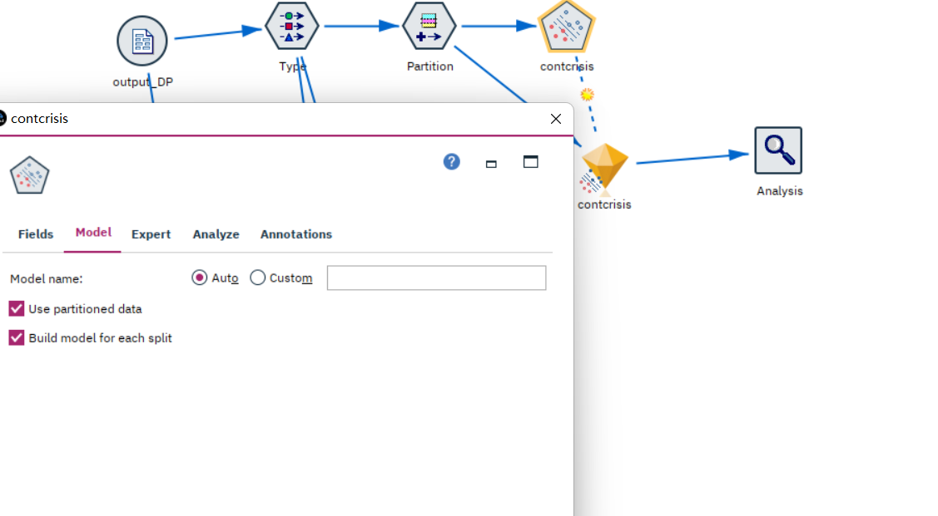

The default build settings are as follow:

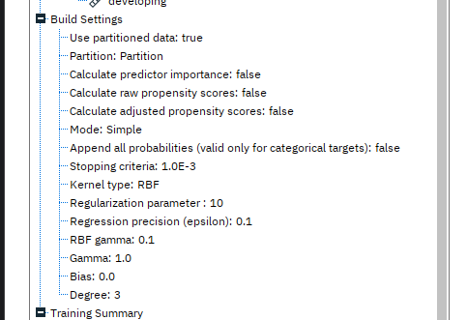

# 7. Data Mining

## 7.1 Create and justify test designs

Divide the dataset into training and testing, 80% for training and 20% for testing.

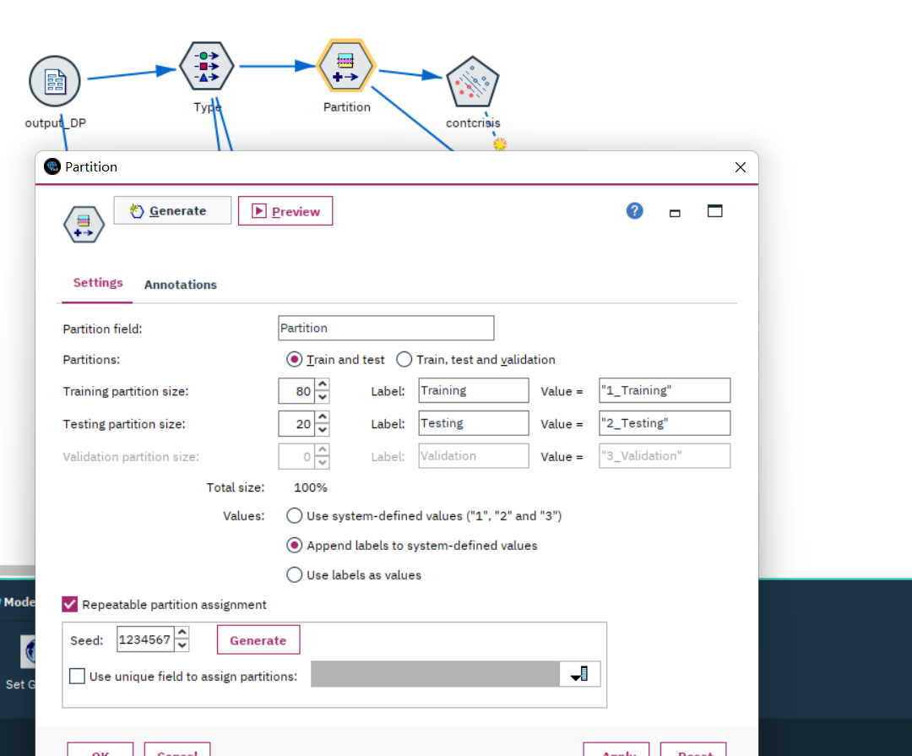

Ensure that the test set remains untouched and separate to provide and unbiased evaluation.

## 7.2 Conduct data mining – classify, regress, cluster, etc. (models must execute)

Binary classification:

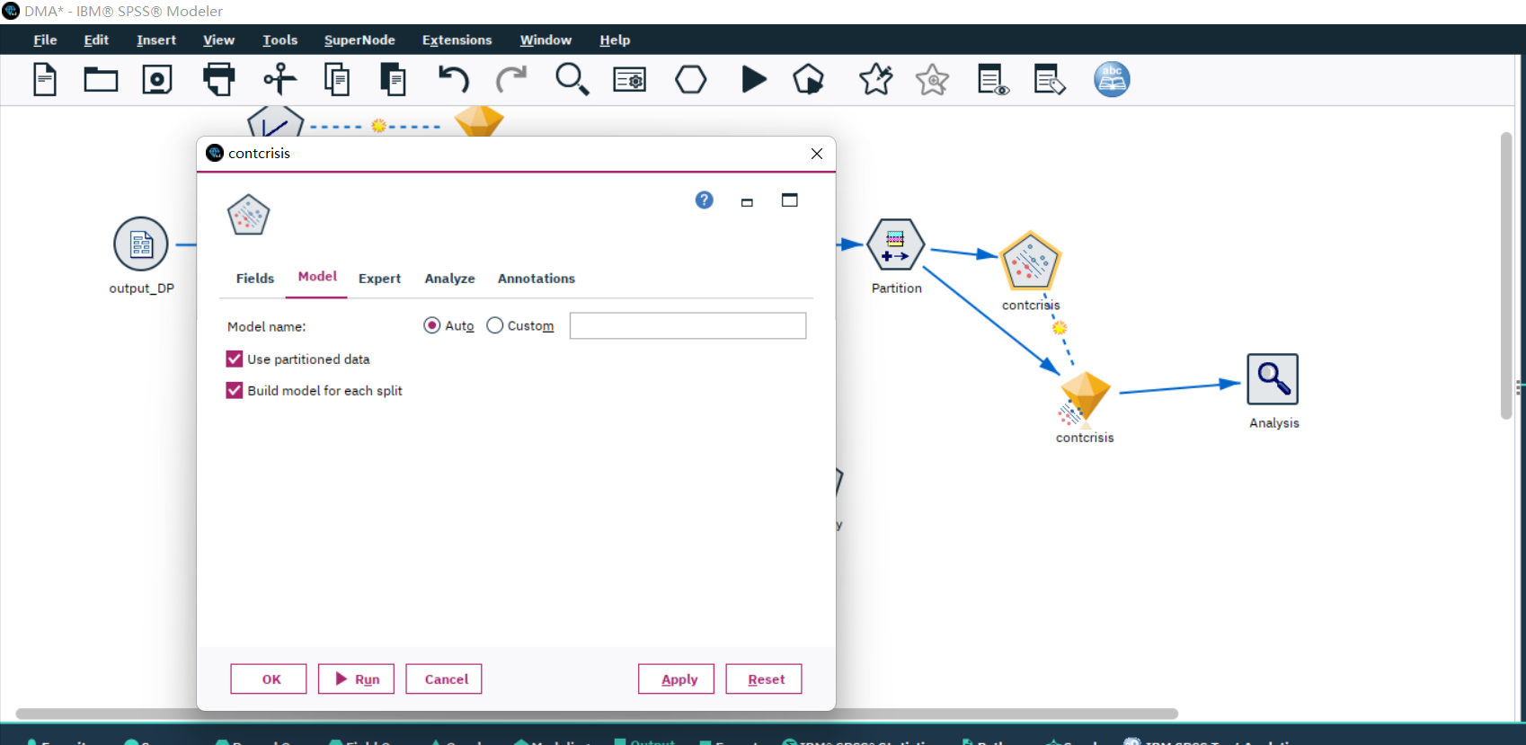

## 7.3 Search for patterns

The binary classification model performs perfect with its 100% correct rate.

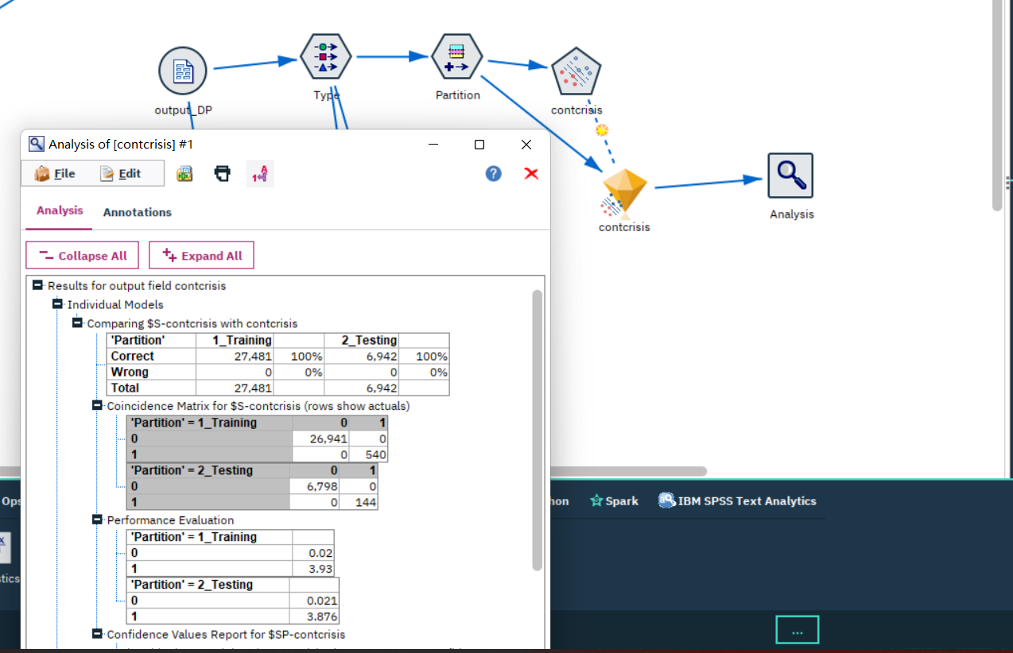

The linear model and regression model are both built unsuccessfully. Another iteration is needed.

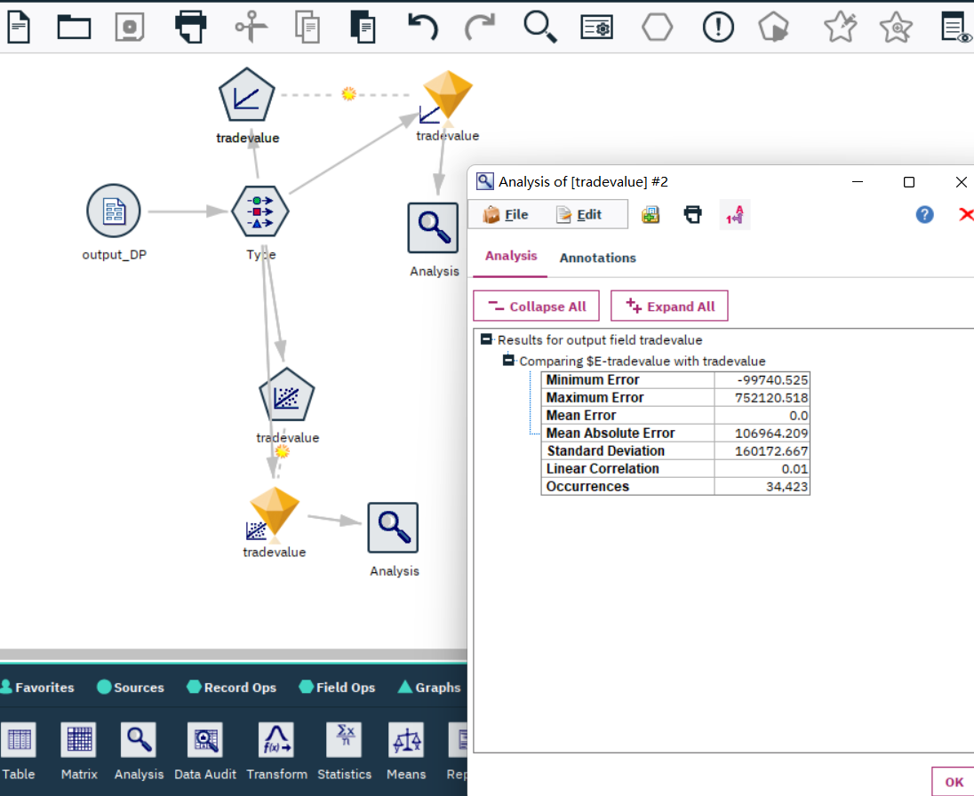

# 8. Interpretation

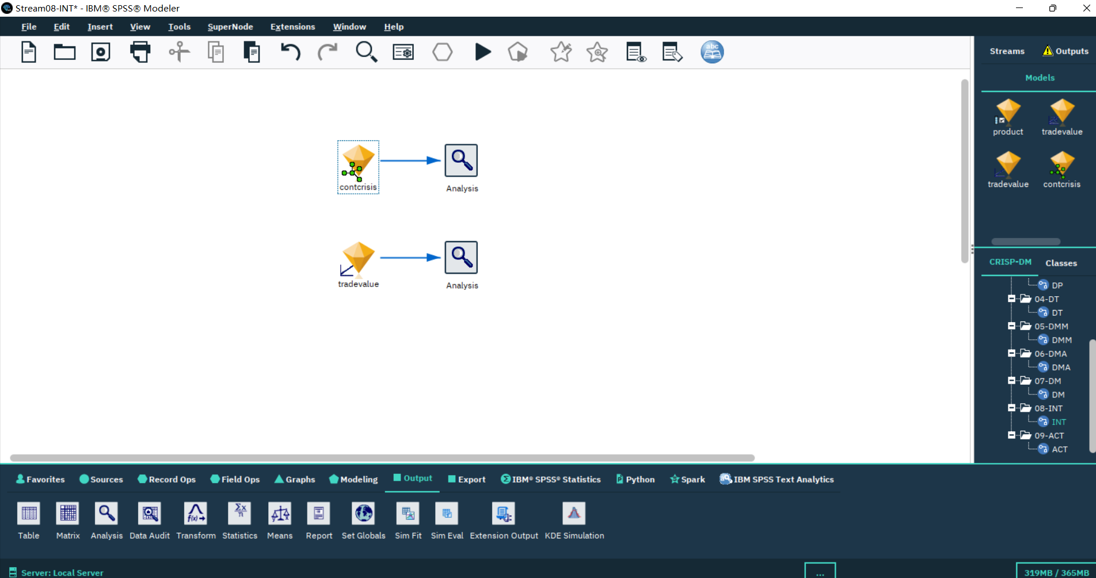

## 8.1 Study and discuss the mined patterns

The model found mined patterns as follow:

The model is a binary classification model, and its target variable is if there is a banking crisis happened.

Linear Relationships:

A continuous decline in GDP Growth Rate combined with rising Unemployment Rate might linearly correlate with the likelihood of a banking crisis.

Interactions between Features:

A combination of high Government Debt to GDP Ratio and a significant Current Account Deficit might increase the risk of a crisis, especially if foreign exchange reserves are low.

Temporal Patterns:

A consistent decline in Foreign Exchange Reserves over several quarters might indicate capital flight, signaling an impending crisis.

Anomalies or Outliers:

A sudden and significant drop in the Stock Market Performance might be an anomalous pattern indicating loss of investor confidence, which can be a precursor to a banking crisis.

## 8.2 Visualize the data, results, models, and patterns

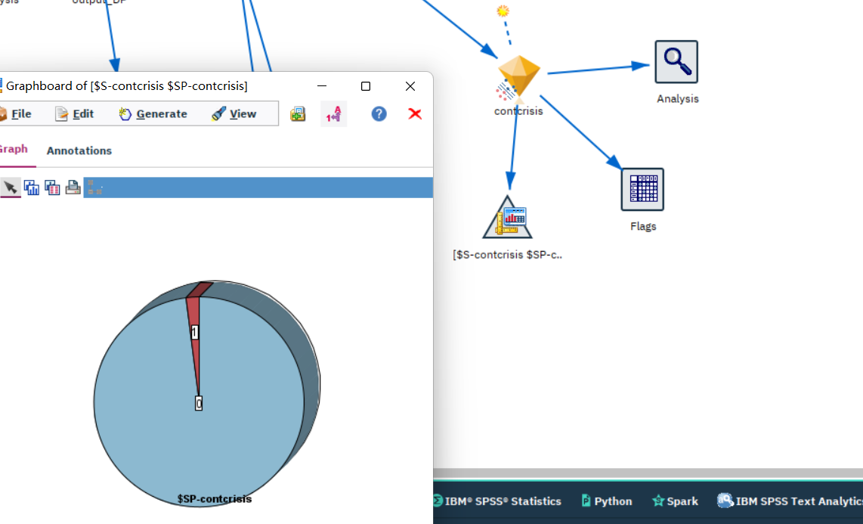

## 8.3 Interpret the results, models, and patterns

Target variable: Churn (1 if there is a banking crisis, 0 if not)

Model: SVM

Model results:

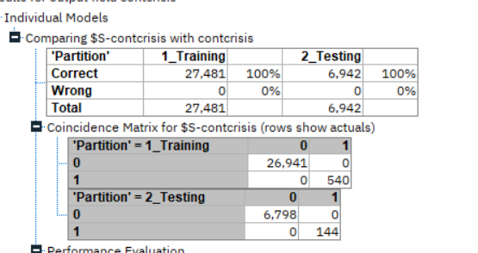

Accuracy: 100%

AUC: 1.0

Gini: 1.0

Performance Evaluation:

## 8.4 Assess and evaluate results, models, and patterns

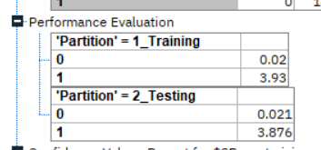

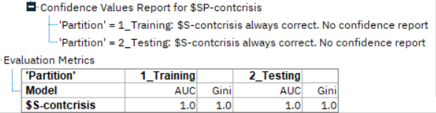

## 8.5 iterations

Data Understanding:

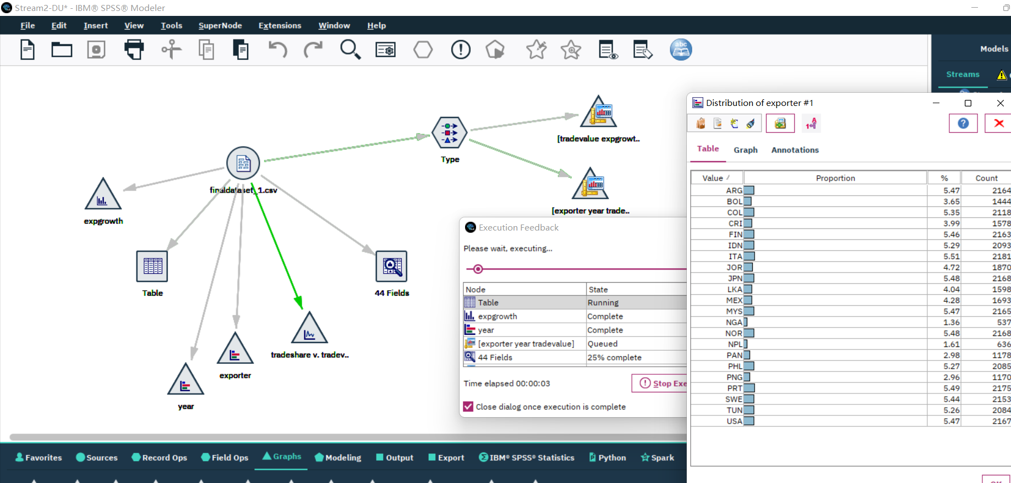

Data Preparation:

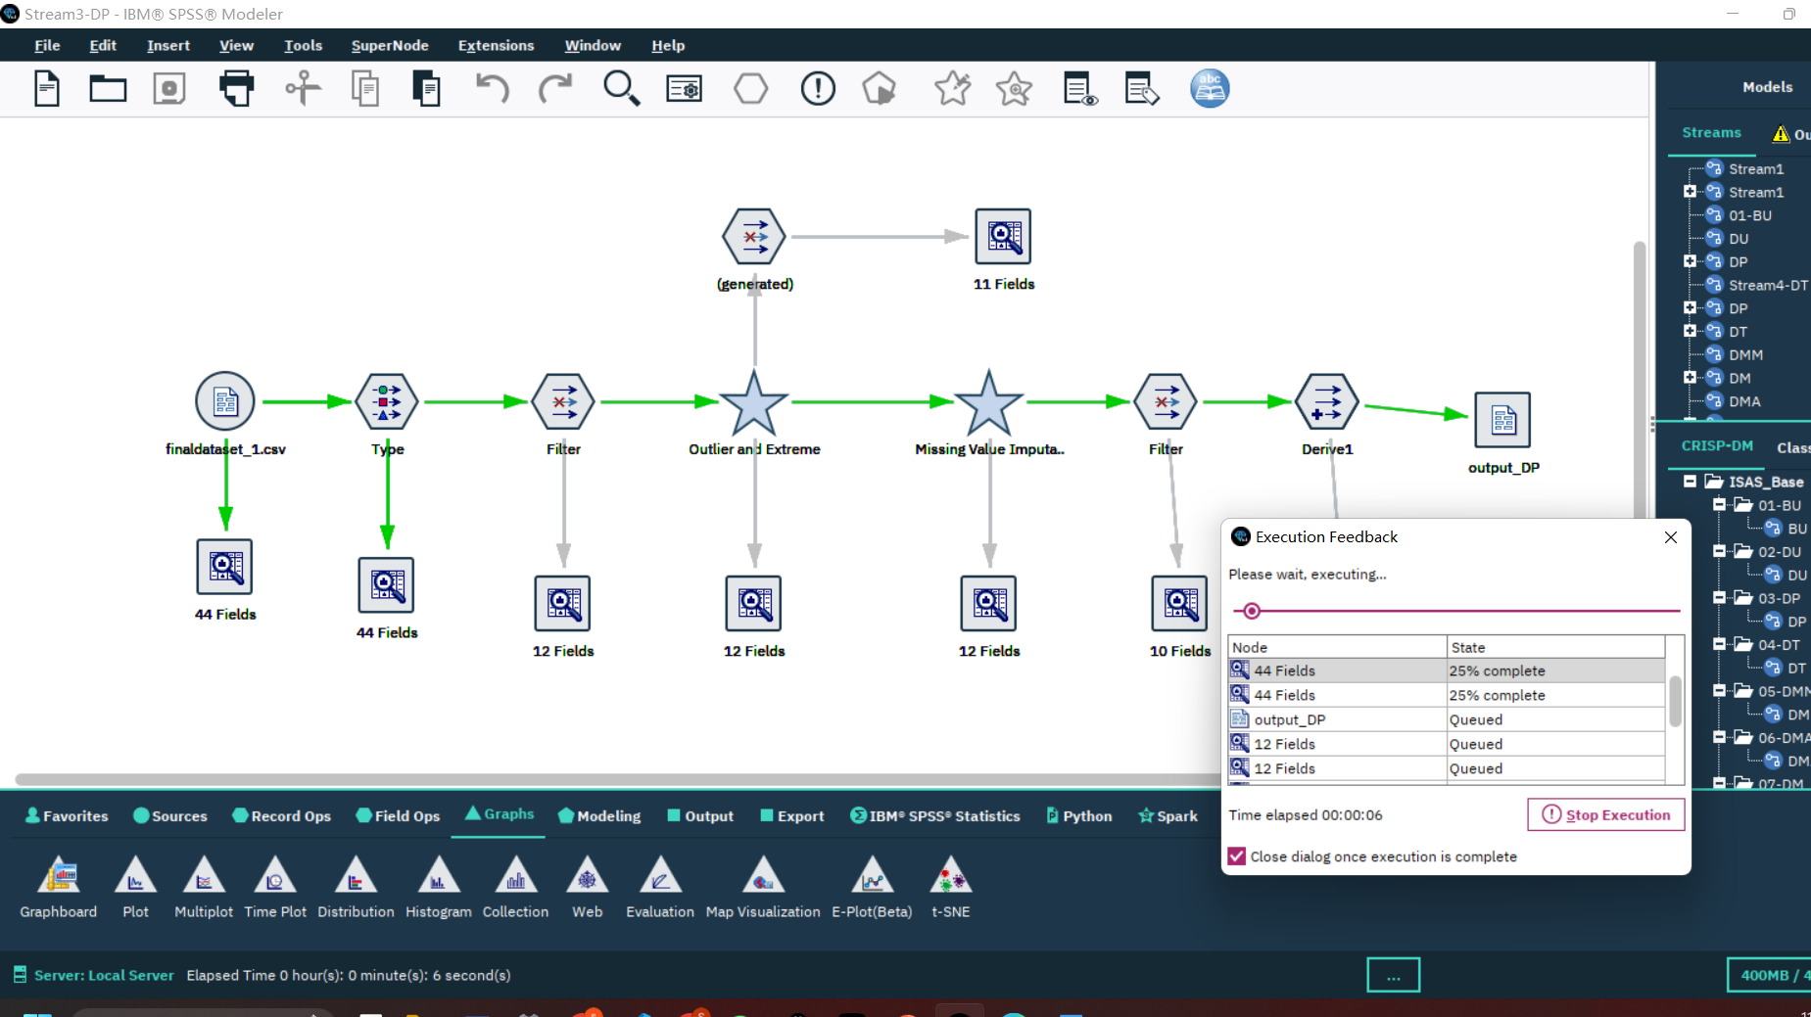

Data Transforming:

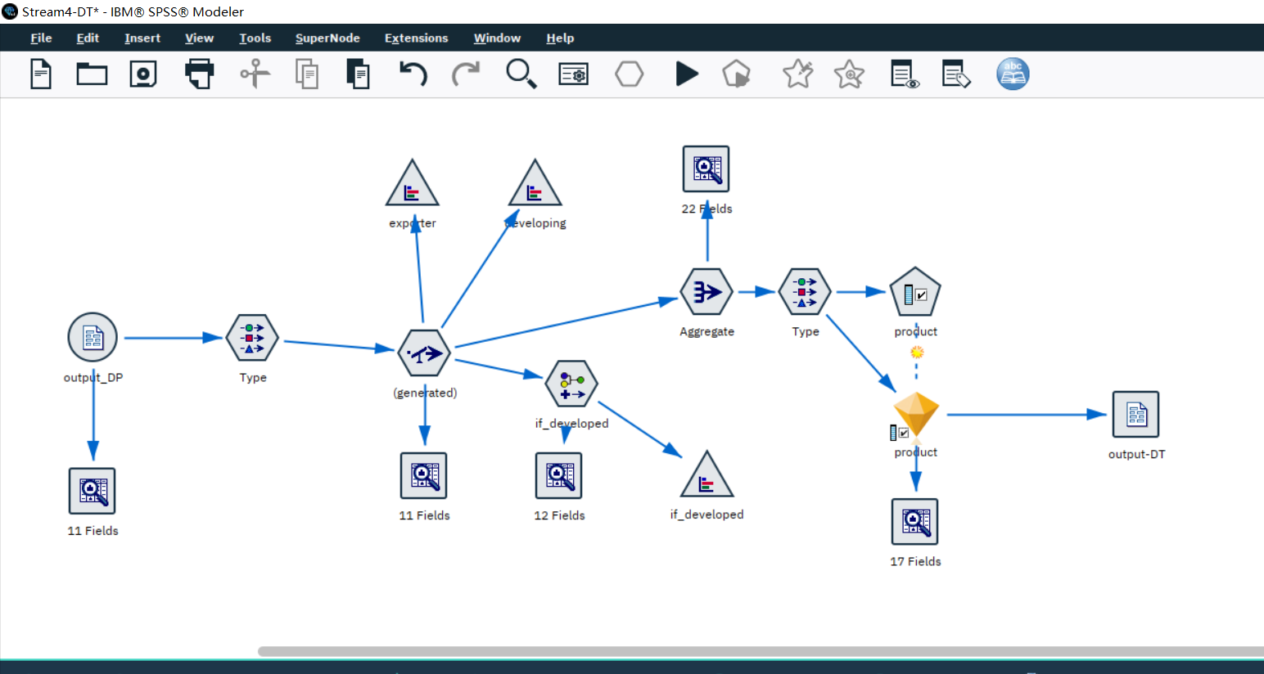

Data Mining Methods & Algorithms:

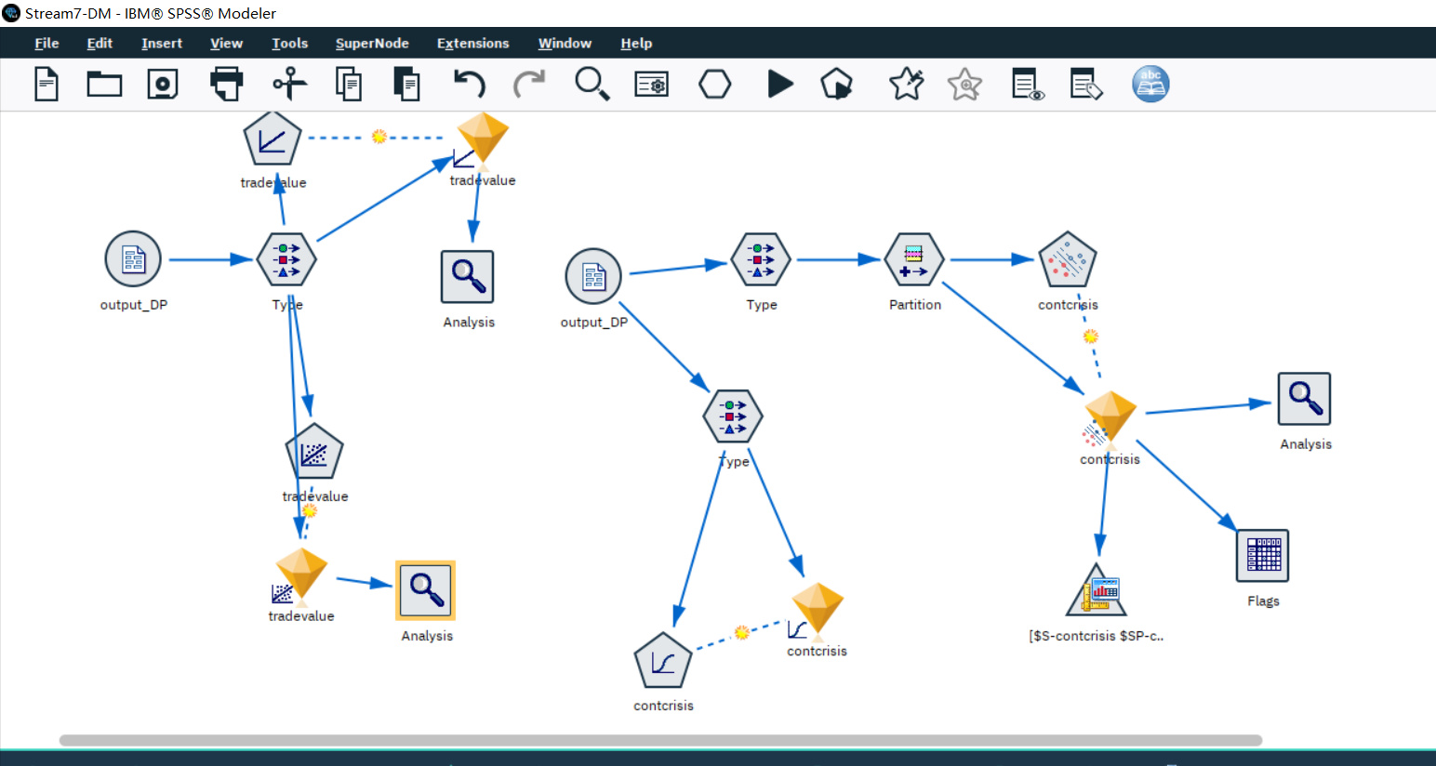

Data Mining:

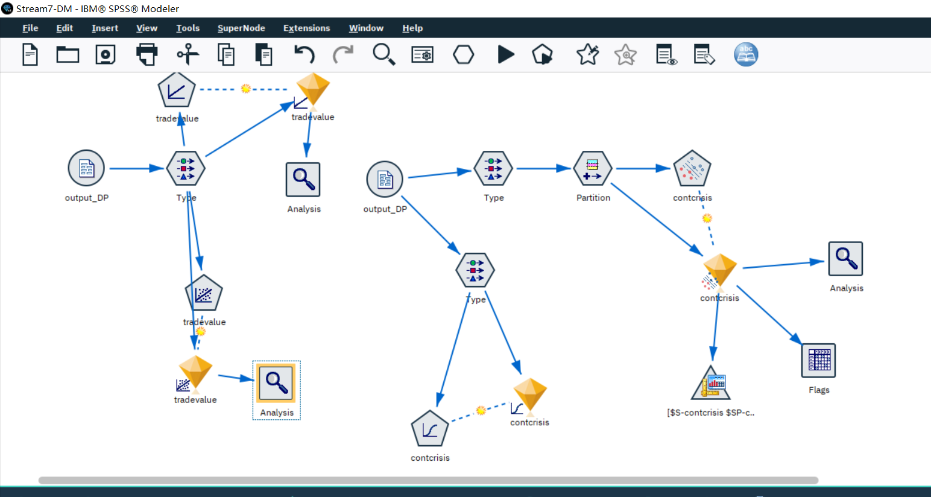

Interpret:

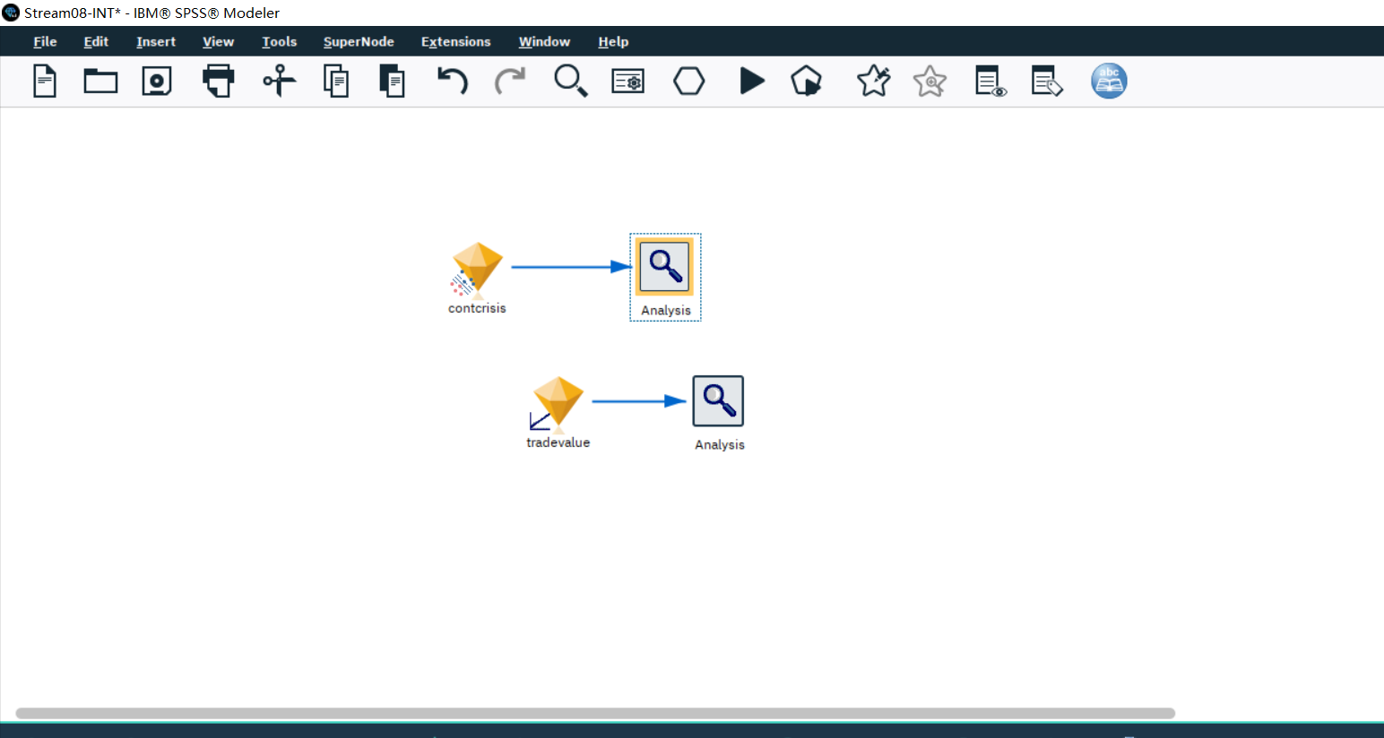

# Disclaimer

I acknowledge that the submitted work is my own original work in accordance with the University of Auckland guidelines and policies on academic and copyright.

I also acknowledge that I have appropriate permission to use the data that I have utilized in this project. This includes permission to upload the data file to Canvas. The University of Auckland bears no responsibility for the student’s misuse of data.